Financial Competitiveness of Coal-to-Methanol versus Green Methanol in China
Cost Drivers, Policy Thresholds, and Valuation Implications

Name: Kevin Zheng
Student Number: 2401213835
Program: Master of Business Administration (MBA)
Advisor: Ying Guang Zhang
Area of Research: Energy & Commodity Markets Pricing
School: Guanghua School of Management

Abstract
Green methanol is not commercially viable in China under current conditions. The median production cost of coal-to-methanol in China is USD 269.8 per tonne, against a median of USD 577.5 per tonne for green (e-methanol) routes—a gap of USD 307.7 per tonne. China's carbon market, which peaked at approximately USD 14.4 per tonne of CO₂ in 2024, adds only USD 33 per tonne to coal methanol's effective cost and closes none of the gap on its own. Green methanol becomes cost-competitive only when three conditions move simultaneously: renewable electricity falls to USD 20–25/MWh, green hydrogen falls to USD 1.45–2.00/kg, and carbon pricing rises to USD 62–80/tCO₂. Under those joint conditions, a representative 200,000-tonne-per-year green methanol plant achieves an internal rate of return near 10%, its cost of capital. Under current conditions, the same project produces a net present value of negative USD 593 million.
This thesis draws on financial data extracted from the annual reports and SEC Form 40-F filings of four publicly listed methanol producers—Methanex Corporation (NASDAQ: MEOH), China Coal Energy Co., Ltd. (HKEX: 1898), China Shenhua Energy Co., Ltd. (HKEX: 1088), and OCI Global (Euronext: OCI)—covering fiscal years 2020 to 2024. The key variables extracted are production volume, sales volume, revenue, EBITDA, capital expenditure, and average realized price per tonne. These company observations are combined with 43 production-cost estimates drawn from 13 peer-reviewed techno-economic studies to produce a cost dataset spanning coal methanol, gas methanol, bio-methanol, and e-methanol pathways.
Among the cost drivers, hydrogen cost and renewable electricity price explain the largest share of the green methanol premium. A USD 10/MWh reduction in electricity reduces e-methanol cost by approximately USD 103 per tonne; a reduction in green hydrogen from USD 3.85/kg to USD 2.00/kg reduces the required carbon price for parity from USD 133.8 to USD 79.5 per tonne of CO₂. No single lever is sufficient; parity requires all three to improve together. An important boundary condition applies: coal-based methanol sells into a broad commodity market spanning petrochemicals, fuel blending, and methanol-to-olefins, while current green methanol projects depend on maritime offtake agreements where buyers pay a compliance premium above commodity price. Full-scale displacement of coal methanol therefore requires green methanol to compete on price across all end-use markets, a more demanding condition than cost parity alone.
The central implication for managers and policymakers is that green methanol in China will not become competitive through any single intervention. Carbon policy, renewable energy deployment, and electrolyzer technology must advance together. This thesis quantifies the specific thresholds at which that convergence produces a commercially viable investment case.

List of Tables
Table 1. Global summary statistics by methanol pathway.
Table 2. Current China coal-methanol and e-methanol cost comparison.
Table 3. Baseline assumptions used in the stylized parity model.
Table 4. Break-even carbon price under alternative renewable-electricity assumptions.
Table 5. Break-even carbon price under alternative green-hydrogen assumptions.
Table 6. Selected public-company benchmark metrics.
Table 7. Stylized project NPV and IRR under alternative scenarios.
Appendix Table A1. Hypothesis assessment.
Appendix Table A2. Sample construction and analytical subsets.

List of Figures
Figure 1. Global methanol cost distributions by pathway.
Figure 2. Current China coal-methanol and e-methanol cost distributions.
Figure 3. Long-run e-methanol cost trajectory in retained projection cases.
Figure 4. Carbon price required for parity under alternative renewable-electricity assumptions.
Figure 5. Carbon price required for parity under alternative green-hydrogen assumptions.
Figure 6. Methanex revenue, implied cost, and EBITDA per tonne, 2020–2024.

1. Introduction
Methanol is a foundational industrial chemical and an increasingly strategic transition fuel. It sits at the intersection of commodity chemicals, fuels, and carbon management. In China, methanol functions not only as a chemical feedstock but also as a platform molecule for downstream coal-chemical integration, including methanol-to-olefins, formaldehyde, acetic acid, and fuel applications. The scale of China's methanol economy means that the country is not a marginal case in the global decarbonization discussion; it is one of the decisive cases. Any serious evaluation of green methanol's future competitiveness must therefore explain why coal-derived methanol continues to dominate in China, how large the present cost advantage remains, and under what conditions that advantage could erode.
The core problem is straightforward to state but difficult to answer rigorously. Coal-to-methanol is commercially mature, integrated into existing coal-chemical parks, and supported by abundant domestic coal resources. Green methanol, by contrast, depends on renewable electricity, electrolysis, low-carbon carbon sources, and high-capital-intensity plant configurations. The former offers low current cost and operational familiarity. The latter offers superior long-run decarbonization potential but a much less favorable short-run financial profile. That tension is often described in binary terms: coal methanol is "cheap but dirty," green methanol is "clean but expensive." Such descriptions are directionally correct but analytically weak. They do not reveal which variables matter most, how large the cost dispersion is within each pathway, which cost reductions are realistic, or how policy and finance interact with engineering design.
This thesis addresses that specific cost and technology gap. The gap is measured here as the USD 307.7 per tonne difference between the median coal-methanol production cost in China (USD 269.8/t) and the median green methanol production cost in China (USD 577.5/t)—a 2.1-times cost premium that cannot be closed by China's current carbon price of approximately USD 14.4/tCO₂ alone. The focus on China is deliberate because China accounts for the majority of global coal methanol production, has the world's largest coal-chemical industrial base, and is simultaneously a leading site for renewable energy deployment. The tension between these two facts—dominant coal-methanol infrastructure on one side, and ambitious renewable build-out on the other—makes China the most financially significant case for studying this transition.
The thesis makes four contributions. The first is empirical: it extracts production cost, revenue, EBITDA, capital expenditure, capacity, sales volume, and utilization data from the annual reports of four publicly listed methanol producers—Methanex Corporation (NASDAQ: MEOH, Form 40-F filings 2020–2024), China Coal Energy Co., Ltd. (HKEX: 1898, annual reports 2020–2024), China Shenhua Energy Co., Ltd. (HKEX: 1088, annual reports 2020–2024), and OCI Global (Euronext: OCI, annual reports 2022–2024)—and combines those company observations with 43 production-cost estimates from 13 peer-reviewed techno-economic studies. The second is analytical: it constructs a China-specific cost comparison rather than relying on global averages, and calculates break-even thresholds for the three most important cost drivers. The third is interpretive: it uses the company financial data to translate abstract cost estimates into realized commercial benchmarks—specifically, Methanex's EBITDA of USD 32–99 per tonne (2020–2024) anchors the range within which incumbent methanol businesses actually operate. The fourth is valuation-oriented: it builds a project-level NPV and IRR model under five scenarios to show where the investment case for green methanol becomes viable (Larsen & Brenøe, 2022).
The empirical argument developed below is deliberately cautious. The thesis does not claim that one model yields a definitive parity date for all projects. Instead, it argues that competitiveness must be treated as a conditional surface shaped by engineering parameters, policy conditions, and capital intensity. The remainder of the thesis is organized as follows. Section 2 explains the scientific and industrial background of coal methanol and green methanol. Section 3 reviews the literature and identifies the gap that this study addresses. Section 4 describes the dataset, sample-construction logic, and modeling framework. Section 5 presents the results, beginning with global pathway distributions and then turning to current China costs, projected green-methanol trajectories, carbon-parity calculations, company benchmarking, and project-level valuation. Section 6 discusses the implications. Section 7 concludes.

2. Scientific and Industrial Background
2.1 Why methanol matters in China's industrial system
Methanol matters in China for reasons that are both industrial and strategic. Industrially, methanol is an intermediate used in formaldehyde, acetic acid, methyl tert-butyl ether, dimethyl ether, and olefin production. Strategically, it is one of the few molecules that can connect coal, natural gas, biomass, captured carbon, hydrogen, and renewable electricity within a single commodity framework. That versatility gives it a special role in China, where energy security, industrial policy, and decarbonization pressure coexist rather than move in a single direction.
In coal-chemical development, methanol serves as a platform molecule because coal can be transformed into synthesis gas and then into methanol, which in turn can be converted into higher-value downstream products. Xu et al. (2017) describe how China's clean-coal technology trajectory used methanol as a platform for integrated systems. That platform logic helps explain the persistence of coal methanol even under decarbonization pressure. A stand-alone methanol plant is one thing; a methanol unit embedded in a coal-to-olefins or coal-chemicals complex is another. Integration affects not only product slate but also heat recovery, utility sharing, by-product handling, and investment logic. This integration is one reason why company-level coal-chemical segment data often do not map neatly onto pure methanol economics.
2.2 Coal-to-methanol: process logic and cost structure
The conventional coal-to-methanol route is scientifically mature. It begins with coal gasification, in which coal reacts with oxygen and steam to form synthesis gas containing carbon monoxide, carbon dioxide, hydrogen, methane, and impurities. Downstream processing adjusts the composition of that gas so that the H₂/CO/CO₂ ratio suits methanol synthesis. Depending on plant design, this may involve water-gas shift, sulfur removal, carbon capture or separation steps, and recycling loops before the gas enters the methanol synthesis reactor. The crude methanol product is then purified through distillation.
This sequence matters financially because most of the process is mature, standardized, and continuously operable. Coal plants are capital intensive, but the technology risk is relatively low compared with emerging green pathways. Variable cost is dominated by coal feedstock, oxygen and utilities, and plant efficiency. The literature retained in the dataset shows a relatively tight current cost cluster for coal methanol. China-focused coal observations lie mainly between USD 253.8/t and USD 322.0/t. The scientific reason for this cost advantage is not mysterious: coal contains both carbon and chemical energy, and once a plant has been built and integrated, the route avoids the need to purchase very large quantities of externally produced hydrogen. High-capacity, continuous operation lowers the fixed-cost burden per tonne.
The problem with coal methanol is its carbon profile. Literature retained in the working dataset reports carbon intensities in the range of roughly 2.0–2.6 tCO₂ per tonne of methanol for conventional or near-conventional coal routes. Xiang et al. (2020) and Khalafalla et al. (2020) show that process integration, hydrogen integration, and carbon-utilization strategies can improve carbon efficiency, but the baseline route remains emissions intensive. That emissions burden is not always priced today, which is precisely why current profitability and long-run social cost diverge. The thesis therefore treats carbon pricing not as an external moral variable but as an economic mechanism that translates an existing physical externality into a cost term.
2.3 Green methanol: pathway definitions and process choices
Green methanol is not one technology. It is a family of pathways whose common feature is the attempt to produce methanol from low-carbon hydrogen and low-carbon carbon sources. In the strictest sense, e-methanol refers to methanol synthesized from hydrogen generated via electrolysis powered by renewable electricity plus carbon from biogenic or captured CO₂. Biomethanol refers to methanol produced from biomass or biogenic feedstocks. Analytically, these categories should be separated whenever possible.
The core scientific difference between coal methanol and e-methanol lies in where hydrogen and carbon come from. The stoichiometric hydrogen requirement for methanol is approximately 0.1875 tonnes of hydrogen per tonne of methanol. Once hydrogen must be produced externally through electrolysis, the economics change dramatically. Using a stylized electrolyzer consumption assumption of 55 kWh/kg H₂, the hydrogen component alone corresponds to around 10.3 MWh of electricity per tonne of methanol. This figure captures only the electrolysis step. Published full-system electricity intensity figures, which include CO₂ compression, methanol synthesis loop compression, distillation, and auxiliaries, typically range from 12 to 14 MWh per tonne. The 10.3 MWh/t figure used in the parity model is therefore a conservative lower bound on electricity consumption, and the sensitivity analysis slightly understates the benefit of cheaper renewable electricity compared with a full-system calculation.
The carbon source also matters. Li P. et al. (2024a) compare renewable e-methanol pathways using fossil CO₂, fossil-capture CO₂, biogenic carbon, and direct air capture. Their reported costs differ materially because the carbon source changes both direct capture cost and the broader process burden. Direct air capture is particularly expensive in the current literature sample, reaching USD 1,415/t in the working dataset. By contrast, pathways that use lower-cost carbon sources or optimize scheduling can be materially cheaper. Zhou et al. (2024) show that co-production choices also matter: an indirect CO₂-to-methanol route coupled with ethylene glycol co-production performs far better than the direct benchmark route. Gu et al. (2022) show that oxygen sales can substantially improve project economics. These observations are crucial because they reveal that green methanol is not just a "high-cost pathway" but a highly parameter-sensitive pathway.
2.4 Why utilization is a scientific and financial variable
One of the most important links between engineering and finance in this thesis is utilization. Renewable-powered systems are fundamentally different from conventional fossil plants because the resource profile is variable. If hydrogen is produced from off-grid or partially merchant renewable electricity, the methanol system must either tolerate variable operation, install storage and oversizing, or accept lower utilization. Each response has cost implications. Lower utilization increases fixed cost per tonne. Oversizing increases capex. Storage adds cost but can smooth operations. Fasihi and Breyer (2024) make this point at a global scale: excellent sites with cheap and complementary renewable resources can move much sooner toward competitiveness than weak sites, which also explains why Chinese provinces in the northwest combine low renewable costs with strong land and resource endowments that could support lower green-methanol costs over time.
2.5 The role of co-products and carbon accounting
A recurring difficulty in methanol comparison is the treatment of co-products. Some studies include oxygen sales, heat integration credits, or co-products such as ethylene glycol. Some assume low-cost biogenic CO₂ or subsidized carbon credits. From an accounting perspective, these choices are legitimate as long as they are transparent. From a comparability perspective, they create problems. An e-methanol estimate that includes a large oxygen credit is not directly comparable to one that does not. The thesis therefore treats co-product-enhanced observations as informative but not identical, part of the distribution, with their role discussed explicitly in the results rather than being hidden inside an average.
2.6 Scientific sources of cost dispersion in e-methanol
The extraordinary dispersion in the e-methanol literature deserves its own explanation because it is central to the empirical results. At least five scientific and engineering mechanisms create wide cost spreads even before financing assumptions are layered on top.
The first mechanism is carbon-source quality. A CO₂ stream from biogas upgrading or an industrial flue gas is not equivalent to direct air capture. Capture cost, purity, compression requirements, transport, and process integration differ materially. The second mechanism is electrolyzer performance. Electrolyzers differ by technology class, capital cost, current density, degradation pattern, part-load flexibility, and balance-of-plant requirements. A project based on alkaline electrolysis with lower capex but less dynamic flexibility may have a different economic optimum from one based on PEM electrolysis with higher capex but stronger ramping performance.
The third mechanism is renewable-system architecture. A project using only solar power behaves differently from a project using a wind-solar hybrid, a partially grid-connected configuration, or a system with storage. The fourth mechanism is synthesis-loop design and plant scale. A smaller demonstration-scale unit may have much higher unit capex than a larger commercial plant. The fifth mechanism is accounting boundary. Some studies report a plant-gate methanol cost. Others report a broader system cost that includes upstream renewable generation and hydrogen production. Some treat oxygen as a co-product credit. Some include carbon capture cost explicitly while others assume a supplied carbon stream. These are not reasons to discard the literature. They are reasons to interpret it as a distribution of plausible outcomes rather than a stack of interchangeable point estimates.
2.7 Why different end-markets affect comparability
Green methanol and coal-based methanol are chemically identical — both are CH₃OH. A cost-per-tonne comparison at the production gate is therefore valid and forms the empirical core of this thesis. However, the two pathways do not currently compete in identical markets, and that asymmetry has consequences for the valuation analysis.
Coal-based methanol is sold into a deep, liquid commodity market. Roughly 20 percent of global methanol demand comes from methanol-to-olefins plants (Methanex, 2025); a further 30 percent is absorbed by formaldehyde and acetic acid production; the remainder flows into MTBE, dimethyl ether, direct fuel blending, and smaller chemical derivatives. This breadth of demand means coal methanol pricing is set by a thick market with many buyers across multiple industries. A coal methanol producer can shift volumes across end-uses in response to relative margins, giving it natural revenue flexibility.
Current green methanol production is overwhelmingly directed toward a single market segment: maritime shipping, where buyers such as Maersk, CMA CGM, and Hapag-Lloyd pay above commodity price through bilateral long-term offtake agreements to meet IMO 2023 GHG Strategy and FuelEU Maritime compliance obligations. That premium is a regulatory compliance premium, not a quality premium. If a green methanol producer attempted to sell into the formaldehyde or MTO markets instead, where buyers have no regulatory incentive to pay above the commodity price, the project would receive coal methanol spot pricing and become financially non-viable at current production costs.
Two implications follow for the analysis in this thesis. First, the LCOM comparison in Section 5 is a production-cost comparison at the plant gate and is methodologically valid regardless of end-market. Second, the valuation scenarios in Section 5.7 are anchored to maritime offtake pricing and are valid only if that market-access assumption holds. A green methanol plant selling into maritime supply at USD 700/t (Scenario 4) or USD 580/t (Scenario 5) is not the same business as a plant competing on price with coal methanol in the MTO or formaldehyde markets. Full displacement of coal methanol across all end-use sectors would require green methanol to reach cost parity with the coal methanol commodity price without a compliance premium — a more demanding threshold than the break-even analysis in Sections 5.4 and 5.5 suggests. The thesis acknowledges this explicitly: cost parity is a necessary but not sufficient condition for complete market displacement.

3. Literature Review and Research Gap
3.1 Coal methanol: maturity, efficiency, and carbon exposure
The coal-methanol literature establishes a clear baseline: coal-based methanol is mature, commercially proven, and currently inexpensive relative to low-carbon alternatives. Xu et al. (2017) frame methanol as a platform within China's clean-coal technology development, showing that coal methanol cannot be interpreted merely as a standalone chemical process but is embedded in an industrial strategy built around domestic resource use and downstream integration. Khalafalla et al. (2020) develop conceptual coal-to-methanol designs with carbon capture and utilization, showing how process configuration influences total annualized cost, energy efficiency, and carbon performance. Xiang et al. (2020) propose a coal-to-methanol route integrated with chemical looping hydrogen and air separation, reporting improved carbon utilization. These studies show that coal methanol is not technologically static.
Yet the coal route's weakness is equally clear. Tu (2024) argues that the Chinese coal-chemical sector faces a progressively more carbon-constrained future. Even if coal chemistry retains an energy-security rationale, it becomes harder to justify in a policy environment that tightens emissions constraints and channels capital toward lower-carbon alternatives. Lv et al. (2024) reinforce this point by showing how carbon taxation can shift the economics of coal-based chemical value chains. The key implication is not that coal methanol suddenly becomes uneconomic under modest carbon pricing, but that policy has the potential to erode the cost advantage that is currently taken as given.
3.2 Green methanol: large dispersion and pathway sensitivity
The green-methanol literature is far more heterogeneous than the coal literature. Gu et al. (2022) provide a China case study of a green methanol plant with optimized renewable hydrogen production, explicitly connecting renewable-system design to downstream methanol economics. The same paper illustrates how co-product treatment changes outcomes: oxygen sales materially lower the estimated cost, showing that the boundary of the project matters significantly for comparability.
Li P. et al. (2024a) compare multiple renewable e-methanol pathways and provide one of the most useful recent datasets for this thesis, spanning pathways with fossil-source CO₂, fossil-capture CO₂, biogenic carbon, and direct air capture. They are particularly helpful because they report the share of total cost attributable to e-hydrogen in different pathways, enabling a structured hydrogen-sensitivity exercise rather than vague qualitative claims.
Zhou et al. (2024) analyze CO₂-to-methanol configurations and show that process design and co-production matter substantially. Their indirect route with ethylene glycol co-production materially outperforms the direct reference route, and they identify a break-even hydrogen threshold near USD 1.88/kg for competitiveness with coal methanol under that specific configuration. That threshold applies specifically to the co-production-optimized pathway analyzed by Zhou et al., not to the median Chinese e-methanol plant used as the baseline in the present thesis. The two analyses are answering different questions: Zhou et al. assess a purpose-optimized industrial design, while this thesis uses the median of the broader China e-methanol literature sample. The USD 1.88/kg threshold remains a valuable engineering reference point but should not be imported as a universal parity condition.
At a more aggregated level, IRENA (2021) synthesizes the renewable-methanol landscape and documents the large current cost premium relative to fossil routes. Fasihi and Breyer (2024) extend the analysis with a high-resolution global resource perspective and project substantial cost declines by 2030, 2040, and 2050. Their global potential framework is highly relevant to this thesis because it shows both the magnitude of the current premium and the plausibility of long-run convergence. Importantly, however, their best-site global results should not be imported mechanically into a China-specific argument; they are benchmark trajectories, not direct China forecasts.
3.3 Hydrogen cost and renewable electricity as the main bottlenecks
A strong consensus emerges from the literature: hydrogen cost is the central bottleneck in green methanol. Li X. et al. (2024b) report that onshore wind-powered hydrogen costs in China range from USD 1.44/kg in Gansu province to USD 2.24/kg in Inner Mongolia under 2030 projections, compared with a current national green hydrogen average of approximately USD 3.85/kg (IEA, 2024a). This regional variation matters directly for methanol economics: at USD 1.44/kg hydrogen, the break-even carbon price for e-methanol parity falls to approximately USD 63/tCO₂ (using: e-cost at H₂=USD 1.44/kg = 414.8/t, parity gap = 145.0, CP = 145.0 ÷ 2.3 = 63.0/tCO₂); at USD 2.24/kg, it falls to approximately USD 87/tCO₂; at the current USD 3.85/kg, it requires USD 133.8/tCO₂. China's combination of cheap renewable electricity and the world's lowest electrolyzer manufacturing costs gives Chinese projects a structural cost advantage that is already visible in these regional figures. The relevant question for this thesis is therefore not whether Chinese hydrogen costs will fall, but whether they will fall far enough, and in the right locations, to change methanol competitiveness before 2035.
3.4 The finance gap in the literature
Although the engineering literature is rich, the finance dimension is underdeveloped. Most techno-economic studies stop at levelized cost or total annualized cost. Larsen and Brenøe (2022) represent an important exception, developing a valuation framework for early-stage green transition projects that explicitly accounts for uncertainty, discount rates, and commercialization pathways in the context of green methanol for shipping. Although this is a Copenhagen Business School master's thesis rather than a peer-reviewed journal article, it is cited here for its analytical framework rather than its empirical findings; the NPV and IRR methodology it applies is standard in project finance and is consistent with approaches used in the peer-reviewed literature on energy transition project valuation (Li et al., 2021; Fasihi and Breyer, 2024). Their work demonstrates that projects can become commercially interesting before they are commercially optimal if strategic offtake structures and policy support can bridge the gap to maturity. This thesis draws on that framework in the valuation section (Section 5.7) to connect cost-gap findings to investment attractiveness.
The demand literature also notes that shipping decarbonization has created early strategic demand for green methanol (OCI, 2024). However, demand does not eliminate production economics. An offtake agreement can lower revenue risk, but it does not by itself erase a large cost premium unless the buyer is willing to pay it, policy bridges the difference, or both. The analysis in Section 5.7 quantifies this point directly through NPV and IRR comparisons.
3.5 Carbon-neutrality roadmaps and macro context
China-specific system transition analysis provides important macro context for evaluating green methanol competitiveness. Li et al. (2021) develop a quantitative roadmap toward China's 2060 carbon neutrality using methanol and ammonia as energy carriers, implying that the long-run viability of green methanol is linked to broader electrification and renewable deployment. Bazaluk et al. (2020) focus on China's green methanol production potential and quantify economic and environmental benefits, reinforcing that potential exists but that deployment requires overcoming high costs and coordination barriers. The methanol price and commodity chain literature, including Luo et al. (2023) on methanol futures forecasting and Yang et al. (2024) on petrochemical chain integration, provides empirical grounding for incorporating realistic price uncertainty into valuation scenarios.
3.6 Research gap and hypotheses
The literature therefore leaves three gaps. First, existing work often compares pathways without carefully separating global descriptive evidence from jurisdiction-specific policy modeling. Second, much of the literature identifies cost drivers qualitatively but does not integrate them into a transparent break-even framework anchored in China-specific medians and scenario ranges. Third, the link between engineering costs and financial interpretation remains weak, and no prior China-focused study has extended the cost analysis into a project-level NPV and IRR framework using public-company data as commercial anchors.
The thesis addresses these gaps through three hypotheses. H1 states that under current Chinese conditions, green methanol remains more expensive than coal methanol on a levelized-cost basis. H2 states that the principal drivers of that gap are hydrogen cost and renewable-electricity cost, with carbon-source choice and utilization acting as additional amplifiers. H3 states that green methanol reaches parity with coal methanol only under joint movements in policy and technology—specifically, lower renewable-electricity cost, lower hydrogen cost, and higher carbon pricing—and that this joint condition is required for a financially viable investment case as well as a cost-parity outcome.
3.7 Chinese government policy: squeezing coal methanol costs and subsidising green methanol
The competitive dynamics between coal-based and green methanol in China cannot be fully understood from engineering costs alone. Government policy is reshaping the cost structure of both pathways simultaneously, and the trajectory of that intervention is one of the most analytically consequential dimensions of the competitiveness question. Two sets of policies are running in parallel: a tightening regulatory and carbon-pricing framework that progressively raises the effective cost of coal-based methanol production, and an expanding subsidy and industrial-policy architecture that is compressing the cost of green methanol from the other direction. Whether these two trends will converge fast enough to matter before 2030 is an open empirical question, but the direction is unambiguous.
Policies raising coal methanol costs. The single most consequential mechanism is the national Emissions Trading System (ETS). Launched July 16, 2021 by the Ministry of Ecology and Environment (MEE), the ETS initially covered only the power sector. In March 2025, coverage expanded to steel, cement, and aluminum. The landmark joint CPC Central Committee and State Council opinion of August 25, 2025 explicitly mandated ETS coverage of all major industrial emitting sectors by approximately 2027, with coal chemicals named among the next-wave sectors (ICAP, 2025). Carbon prices have risen from approximately 48 RMB/tCO₂ at launch to an annual average of 98 RMB/tCO₂ in 2024, peaking at 104.5 RMB before correcting. Forecasts from IEA (2024b) and the World Bank (2025) project carbon prices in China's industrial sectors reaching 100–200 RMB/tCO₂ by 2030, with the World Bank's Paris-aligned scenario recommending USD 50–100/tCO₂ (approximately 360–725 RMB/tCO₂) by 2030 for emerging economies. The cost implications are calculable using the same carbon intensity assumed throughout this thesis: 2.3 tCO₂ per tonne of methanol, the midpoint of the 2.0–2.6 tCO₂/t range from peer-reviewed coal-methanol techno-economic studies (consistent with Section 4.5). Note that lifecycle estimates including upstream coal mining and transportation can reach 2.9 tCO₂/t or higher, which would increase the carbon cost burden further; the 2.3 tCO₂/t figure used here is therefore conservative and understates the full policy exposure. At 100 RMB/tCO₂, ETS inclusion would add approximately 230 RMB/tonne to coal methanol cost (2.3 × 100 = 230 RMB); at 200 RMB/tCO₂, the addition reaches 460 RMB/tonne (2.3 × 200 = 460 RMB, approximately USD 63/t at 7.25 RMB/USD), equivalent to about 17–20 percent of current production cost. At 500 RMB/tCO₂, the carbon cost addition would be approximately 1,150 RMB/tonne (2.3 × 500 = 1,150 RMB, approximately USD 159/t) — at this level the effective coal methanol cost exceeds the current green methanol median even without any technology improvement on the green side.
The June 2023 NDRC Notice on Promoting Healthy Development of Modern Coal Chemical Industry (Issue 773) is the most comprehensive regulatory action constraining coal methanol capacity in a decade. Issued jointly by NDRC and five additional ministries (MIIT, MNR, MEE, MWR, MEM), it imposed strict capacity controls, ended the previous per-zone cap system, required Grade A environmental performance for new projects, and enforced the principle that water resources constrain production volumes (NDRC, 2023). Projects in major air pollution prevention regions face outright prohibition on new coal chemical capacity. Existing facilities failing to meet energy efficiency benchmark levels by end-2025 face closure. The Yellow River Protection Law (effective April 1, 2023) adds binding water use limits in the basin where most coal chemical capacity is located. The combined effect of these regulations is to raise both capital costs (for new entrants) and operating costs (via compliance requirements and efficiency mandates) while constraining future capacity growth.
A critical carve-out protects coal methanol in the near term: the exemption of raw-material energy (yuanliaonengyong) from dual-control energy consumption constraints. This exemption treats coal used as chemical feedstock differently from coal burned for energy, shielding methanol producers from energy intensity caps. Coal consumption in the chemicals sector grew approximately 20 percent year-on-year in the first half of 2025 — the only major coal-consuming sector still growing rapidly — specifically because this exemption remains in force. Whether it survives into the 15th Five-Year Plan period (2026–2030) is the most consequential open policy question for coal methanol producers. Its removal would be equivalent in cost impact to a significant carbon price increase applied specifically to the feedstock sector.
Policies supporting green methanol. China’s first national hydrogen strategy, the Medium- and Long-Term Plan for the Development of Hydrogen Energy Industry (2021–2035), issued March 23, 2022, set a target of 100,000–200,000 tonnes of renewable hydrogen annually by 2025 (IEA, 2024a). Provincial ambition far exceeded this: Inner Mongolia alone targeted 480,000 tonnes/year. The scale of China’s electrolyzer manufacturing response has been the most consequential quantitative development. China now accounts for approximately 60–68 percent of global electrolyzer manufacturing capacity (approximately 20 GW/year). Chinese alkaline electrolyzer system costs sit at roughly USD 600–1,200/kW installed — approximately one-third of Western equivalents at USD 2,000–2,600/kW. Stack-only bid prices fell from approximately USD 350/kW in 2021 to approximately USD 150/kW in 2024, a decline of over 57 percent in three years (IEA, 2024a). This mirrors the solar panel manufacturing trajectory and creates a durable structural cost advantage in downstream green hydrogen and green methanol production.
Direct financial subsidies for green methanol arrived with the October 14, 2025 NDRC Decarbonisation Project funding method, which provides a 20 percent capital expenditure subsidy for green methanol, green ammonia, sustainable aviation fuel, and CCUS projects. This reduces effective project capex by approximately one-fifth. A further escalation came with the March 16, 2026 joint MIIT-MOF-NDRC pilot programme, providing a total national reward pool of RMB 8 billion across five city clusters over four years, targeting hydrogen prices below RMB 25/kg by 2030 and explicitly prohibiting coal-based methanol from qualifying under the green label. The China Energy Law (effective April 2025) reclassified hydrogen as an energy resource rather than a hazardous chemical, materially reducing regulatory barriers to production, storage, and transport.
Assessment: are subsidies building genuine competitiveness or simply propping up an uncompetitive industry? The honest answer differs by market segment. For maritime-oriented green methanol, Chinese policy is constructing genuine competitive infrastructure. The convergence of electrolyzer overcapacity (mirroring the solar playbook), cheap renewable resources in western China, direct capital subsidies, and export-market pull from IMO GHG regulation creates a plausible path to cost-competitive production in advantaged regions. Green methanol sold to Maersk, CMA CGM, and Hapag-Lloyd under long-term compliance-driven offtake is being produced at a green premium that the market is absorbing for regulatory reasons, not because the product commands intrinsic quality premium. This segment is policy-enabled but increasingly market-driven.
For domestic substitution of coal methanol in formaldehyde, MTO, and MTBE applications, current subsidies are insufficient to close the gap. The current carbon price adds roughly 290 RMB/t to coal methanol costs even if coal chemicals were covered by the ETS today, against a gap of approximately 1,500–3,500 RMB/t. A 20 percent CAPEX subsidy reduces green methanol capital cost but does not address the dominant variable-cost driver of electricity and hydrogen cost. Regional parity in Inner Mongolia and Xinjiang may be achievable by 2028–2030 given falling electricity costs and electrolyzer learning, but national-scale commodity-market parity requires until 2032–2038 under most projections.
The five-variable conclusion aligns directly with H3. Coal methanol will not be commercially displaced in China's broad chemical markets by green methanol under current policy conditions alone. Competitive parity in the domestic commodity market requires simultaneous progress on: ETS carbon price reaching 300–500 RMB/tCO₂, renewable electricity reaching 0.10–0.15 RMB/kWh in resource-rich provinces, electrolyzer system costs reaching USD 200–400/kW, the raw-material energy exemption being narrowed or removed, and long-term offtake structures reducing revenue risk for new green methanol projects. The policy architecture reviewed here is consistent with that set of conditions emerging in advantaged regions before 2035, but only if the pace of ETS tightening accelerates beyond current projections.

4. Data and Methodology
4.1 Dataset construction and analytical separation
The empirical base of the thesis comprises two distinct source types combined into one structured dataset. The first source type is company financial data extracted from the annual reports and regulatory filings of four publicly listed methanol producers. Methanex Corporation (NASDAQ: MEOH / TSX: MX), the world's largest methanol producer, provided five years of data (fiscal years 2020–2024) from annual reports filed with the U.S. Securities and Exchange Commission as Form 40-F (CIK 0000886977) (Methanex, 2025). China Coal Energy Co., Ltd. (HKEX: 1898 / SSE: 601898) provided coal-chemical segment data from annual reports filed on the Hong Kong Stock Exchange (China Coal Energy, 2025). China Shenhua Energy Co., Ltd. (HKEX: 1088 / SSE: 601088) provided coal-chemical segment data from HKEX-listed annual reports (China Shenhua Energy, 2025). OCI Global (Euronext: OCI) provided methanol segment data from annual reports for 2022–2024 (OCI, 2024; OCI, 2025). From each company filing, the following variables were extracted: (1) total production volume in metric tonnes; (2) total sales volume in metric tonnes; (3) total revenue in USD; (4) adjusted EBITDA or operating profit in USD; (5) capital expenditure in USD; (6) nameplate capacity in tonnes per year; and (7) average realized price per tonne where disclosed. From these inputs, three derived metrics were computed: revenue per tonne (revenue divided by sales volume), EBITDA per tonne (EBITDA divided by sales volume), and capital expenditure intensity (capital expenditure divided by nameplate capacity). These four companies were selected for three specific reasons. First, each is publicly listed on a major exchange and publishes annual financial reports in English, providing audited, reproducible data. Second, each discloses either methanol-specific or coal-chemical segment financial data at a level of detail sufficient to calculate revenue per tonne, EBITDA per tonne, and capital expenditure intensity. Third, together they represent the full spectrum of methanol production pathways relevant to this thesis: Methanex provides a global natural-gas-based benchmark; China Coal Energy and China Shenhua provide China-specific coal-chemical benchmarks; and OCI provides a green and bio-methanol transition reference. No other publicly listed company met all three criteria simultaneously for the period 2020–2024. The second source type is production-cost estimates drawn from 13 peer-reviewed techno-economic studies, yielding 43 direct cost observations across coal methanol, gas methanol, bio-methanol, and e-methanol pathways.
This separation is essential. If a carbon-price scenario row is treated as though it were a methanol-cost observation, the sample becomes incoherent. If a company EBITDA observation is averaged together with literature LCOM estimates, the resulting statistic is not interpretable. The thesis therefore uses a master sheet for data management but separate analytical subsets for substantive analysis.
4.2 Standardization rules
All reported monetary values in the working sheet are retained in nominal USD in the source year indicated by the CurrencyYear field. This preserves traceability and avoids false precision. The thesis does not force all observations into a single real-year price basis because the original source mix is too heterogeneous and because the main comparative logic depends more on relative pathway differences than on inflation adjustments. As a robustness check: inflating the earliest retained coal methanol observations (2017, USD 253.8/t) to 2024 USD at 3 percent annual inflation would increase the value to approximately USD 312/t. The China coal median of USD 269.8/t lies within this range, confirming that the gap with green methanol is not an artifact of the nominal comparison. Volumes are retained in metric tonnes and plant capacities in tonnes per year. Company metrics are calculated only when the relevant fields are available. Revenue per tonne is defined as revenue divided by sales volume; EBITDA per tonne as EBITDA divided by sales volume; capex intensity as capex divided by nameplate annual capacity.
4.3 Cost-comparison sample
The cost-comparison sample includes rows with a populated methanol-cost-per-tonne field and a methanol pathway label, yielding 43 direct cost observations across five pathway groups: coal methanol, gas methanol, bio-methanol, e-methanol, and coal-plus-green-hydrogen hybrid configurations. A second subset is constructed for current China comparisons, restricting to China observations dated 2024 or earlier and limiting the comparison to coal methanol and e-methanol. Projected 2030–2050 e-methanol costs are not averaged into current competitiveness, and global best-site values are not used as China current values.
Two observations from Gu et al. (2022)—one reporting cost with oxygen sales revenue credited and one without—are both retained in the global e-methanol sample to reflect the full range of co-product accounting choices documented in that study. Their inclusion does not constitute double-counting because the two observations capture materially different cost outcomes from the same plant design. However, in the current China parity baseline, only the no-oxygen-credit case (USD 964/t) is used as the primary reference to ensure that China comparisons are not artificially improved by co-product assumptions that are not universally applicable to unintegrated standalone plants. A further comparability boundary is that the parity analysis compares production costs at the plant gate for the same chemical molecule (CH₃OH). This is the correct scope for an LCOM comparison. It does not imply that a green methanol plant could immediately sell into coal methanol's existing end-use markets — formaldehyde, MTO, MTBE, acetic acid, and fuel blending — at the same realized price. Those markets are commodity-priced and buyers have no current compliance incentive to pay a green premium. The valuation scenarios in Section 5.7 therefore specify the market assumption per scenario: Scenarios 3 and 4 assume maritime offtake where a compliance premium applies; only Scenario 5 tests conditions approaching broad commodity competitiveness.
4.4 Descriptive statistical methods
Descriptive statistics are calculated for each pathway group: mean, median, standard deviation, minimum, maximum, first quartile, and third quartile. The median is particularly important because the e-methanol literature contains high-cost outliers, especially direct-air-capture cases, that can distort the mean. At the same time, the mean remains informative because it captures the real breadth of cost outcomes. Rather than choosing between mean and median, the thesis reports both and interprets the gap between them as evidence of distribution shape.
4.5 Stylized parity model
The parity model is intentionally transparent rather than overly elaborate. It asks a focused question: given the current China median cost gap, how large must carbon pricing be to close the gap under alternative renewable-electricity or green-hydrogen assumptions? The baseline coal-methanol cost is set at USD 269.8/t, the median of the current China coal sample. The baseline China e-methanol cost is set at USD 577.5/t, the median of the current China e-methanol sample. Coal-route carbon intensity is set at 2.3 tCO₂ per tonne of methanol, the midpoint of the 2.0–2.6 tCO₂/t range retained across the coal literature.
Two parity representations are used. The first varies renewable-electricity cost using the stoichiometric hydrogen requirement of 0.1875 t H₂/t methanol and an assumed electrolyzer electricity consumption of 55 kWh/kg H₂, yielding a stylized electricity sensitivity of 10.3 MWh per tonne of methanol. As noted in Section 2.3, this figure understates full-system electricity intensity (typically 12–14 MWh/t) and therefore makes the electricity sensitivity analysis conservative. The second representation varies green-hydrogen cost, scaling the hydrogen component of e-methanol cost proportionally with hydrogen price relative to the baseline USD 3.85/kg anchor. The hydrogen component is approximated as 45% of the baseline e-methanol cost, based on the midpoint of the 31%–59% range reported by Li P. et al. (2024a).
The 45% midpoint is not a symmetric average. The 31% share applies to the fossil CO₂ pathway, which is the cheapest e-methanol configuration in Li P. et al. (2024a); the 59% share applies to the biogenic carbon pathway, which is more expensive. Using 45% therefore represents neither pathway specifically but provides a neutral central case. Using the 31% assumption would reduce the hydrogen sensitivity (the parity threshold changes less with hydrogen cost); using 59% would amplify it. These bounds can be computed from the formula in Appendix B and would shift the parity curves in Figure 5 but would not alter the directional conclusion.
4.6 Company benchmark methodology
The public-company benchmark stage uses financial observations from the four listed companies described in Section 4.1. In addition, project-level capital expenditure estimates for European Energy's Kassø e-methanol facility in Denmark are included as a green methanol capex benchmark. European Energy is not publicly listed on a major exchange and does not publish audited segment financials in the same format as the four primary companies; the Kassø data are therefore used only for capital intensity comparison (USD 2,048–3,333/tpy), not as a revenue or EBITDA benchmark. Methanex is the most useful benchmark because it provides multiple years of realized prices, EBITDA, and capex information in a relatively clean methanol-focused format. Its data are drawn from annual reports filed with the U.S. Securities and Exchange Commission as Form 40-F (CIK 0000886977) for fiscal years 2020–2024 (Methanex, 2025). OCI Global is useful as a historical methanol and green-methanol-adjacent case; annual reports for 2023 and 2024 are used (OCI, 2024; OCI, 2025). China Coal Energy and China Shenhua provide China coal-chemical references from their most recent annual reports (China Coal Energy, 2025; China Shenhua Energy, 2025), though the thesis does not treat their segment numbers as pure methanol economics where the disclosures do not support that interpretation.
4.7 Project valuation methodology
Section 5.7 extends the analysis into a stylized project valuation following the approach developed by Larsen and Brenøe (2022) for early-stage green transition projects. Five scenarios are analyzed for a representative 200,000-tonne-per-year plant at 85% utilization over a 20-year project life. Free cash flow is computed as net operating profit after tax plus depreciation, using a 25% China corporate tax rate and straight-line depreciation over 20 years. The discount rate is 8% for coal methanol projects (reflecting state-enterprise or well-established industrial financing) and 10% for green methanol projects (reflecting higher technology risk and earlier commercial stage). These rates are working assumptions informed by general practice in Chinese energy project finance: state-owned enterprise (SOE) methanol projects in China typically access long-term bank financing at rates consistent with a project WACC of 7–9 percent, while early-stage technology projects with higher uncertainty typically require 9–12 percent to attract equity capital. The company benchmark data (Methanex, OCI) do not disclose WACC directly; the rates used here are analytical assumptions, not values derived from the financial disclosures. Capital expenditure assumptions for coal methanol reflect Chinese greenfield benchmarks, which are materially lower than the Saudi Arabian designs in Khalafalla et al. (2020) because of lower construction costs and simpler designs without integrated carbon capture.
4.8 Limitations
The study faces three major limitations. First, the literature observations are heterogeneous in system boundary, co-product treatment, discount rate, and geography. Second, the company sample is informative but not large enough to support strong statistical inference. Third, the parity model and valuation scenarios are stylized. They isolate cost drivers transparently, but they do not model debt structure, tax incentives, or plant-specific engineering integration. These limitations define what can and cannot be claimed. The thesis therefore treats the results as a structured competitiveness assessment rather than a complete project-finance manual.

5. Results
5.1 Global pathway distributions
The first result is simple but important: the global cost distributions by pathway are widely separated. In the cleaned cost-comparison sample, coal methanol has a mean cost of USD 246.4/t and a median of USD 263.0/t. Gas methanol has a mean of USD 224.7/t and a median of USD 250.0/t. Bio-methanol is materially more expensive, with a mean of USD 569.5/t and a median of USD 594.0/t. E-methanol is the most expensive pathway in the current and near-term sample, with a mean of USD 777.1/t and a median of USD 651.5/t.
Two features of these distributions deserve emphasis. The first is that the coal and gas distributions are relatively tight compared with e-methanol, reflecting technological maturity and lower dependence on uncertain or highly variable system parameters. The second is that e-methanol's dispersion is extremely wide—running from USD 340/t to USD 1,642/t in the working sample. That breadth reflects real differences in carbon source, electricity price, renewable profile, plant scale, co-product treatment, and projection horizon. Any statement such as "green methanol costs X dollars per tonne" is therefore too blunt to be analytically useful. A fifth pathway also appears in Table 1: coal methanol with green hydrogen substitution (Coal+Green H₂, N=2, mean USD 340.8/t). These two observations, drawn from Xiang et al. (2020) and Khalafalla et al. (2020), represent hybrid designs in which coal gasification is combined with externally supplied or partially green hydrogen to improve carbon efficiency. Their cost of USD 315–366/t sits between conventional coal methanol and fully electrolytic green methanol, illustrating that partial decarbonization through hydrogen blending can be achieved at a much lower cost premium than a full pathway switch. This hybrid route is not analyzed in the main parity model but represents an intermediate technology option relevant to China's near-term transition.
Table 1. Global summary statistics by methanol pathway.
Pathway | N | Mean (USD/t) | Median (USD/t) | Std. Dev. (USD/t) | Min (USD/t) | Max (USD/t) | Q1 (USD/t) | Q3 (USD/t)
Coal Methanol | 8 | 246.4 | 263.0 | 61.6 | 142.5 | 322.0 | 231.3 | 277.0
Gas Methanol | 3 | 224.7 | 250.0 | 114.1 | 100.0 | 324.0 | 175.0 | 287.0
Bio-Methanol | 4 | 569.5 | 594.0 | 191.0 | 320.0 | 770.0 | 485.0 | 678.5
Green Methanol | 26 | 777.1 | 651.5 | 407.9 | 340.0 | 1,642.0 | 468.8 | 925.5
Coal + Green H₂ | 2 | 340.8 | 340.8 | 35.7 | 315.5 | 366.0 | 328.1 | 353.4

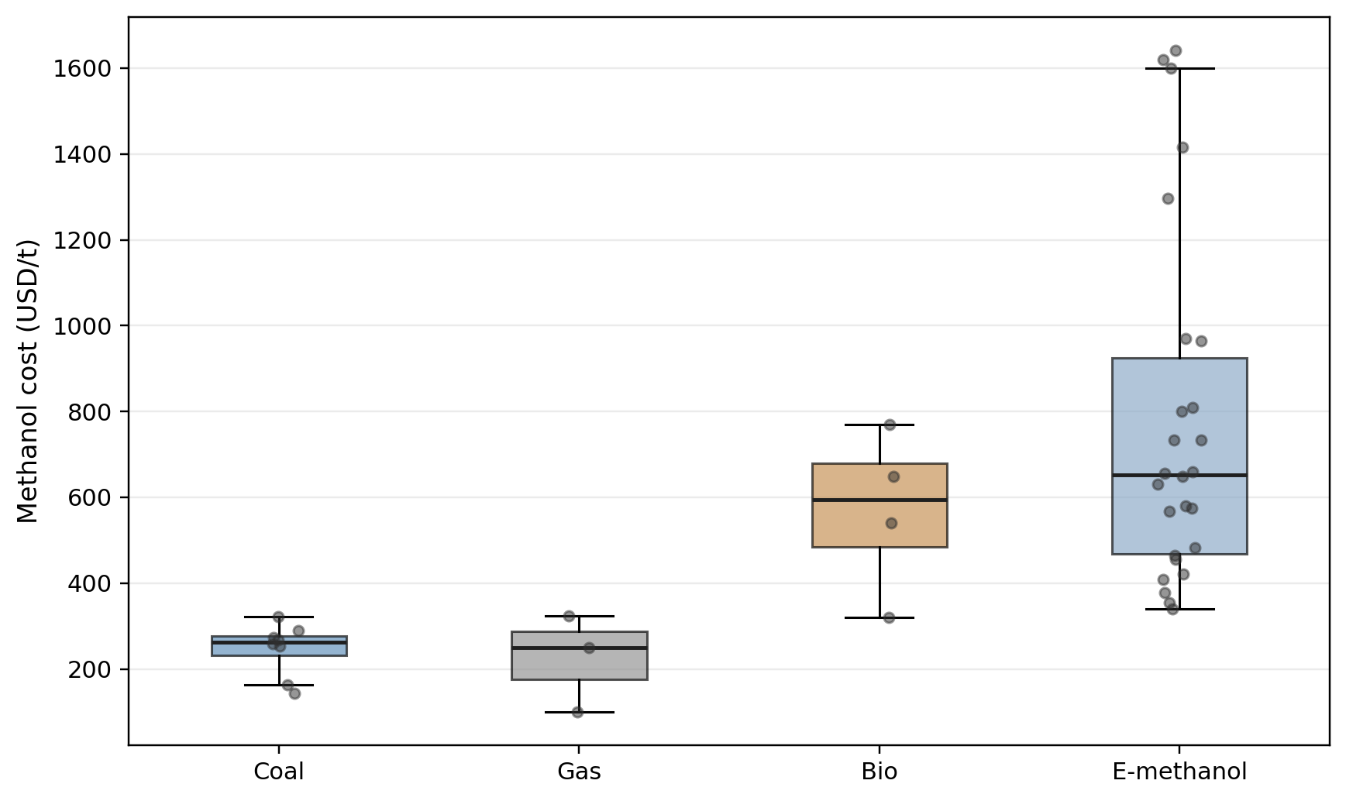
Figure 1. Box plots of production cost per tonne (USD) for five methanol pathways across the global literature sample (N=43). Coal and gas methanol cluster between USD 100 and USD 324/t; e-methanol spans USD 340 to USD 1,642/t, with median USD 651.5/t.
5.2 Current China cost gap
The China current subset, summarized in Table 2 and visualized in Figure 2, is more directly relevant to H1. Restricting the sample to China observations dated 2024 or earlier, the median coal-methanol cost is USD 269.8/t and the median e-methanol cost is USD 577.5/t, implying a median gap of USD 307.7/t. The six China coal-methanol observations, ordered from lowest to highest, are drawn from: Xu et al. (2017) at USD 253.8/t (Shenhua Ningmei CTC baseline); Khalafalla et al. (2020) at USD 261.0/t; Xiang et al. (2020) at USD 269.8/t (baseline case without hydrogen integration); Lv et al. (2024) at USD 277.0/t; Gu et al. (2022) at USD 285.6/t (coal feedstock component only); and Tu (2024) at USD 322.0/t (high-cost scenario including upgraded environmental compliance). The median of the 3rd and 4th ordered values = (269.8 + 277.0)/2 = USD 273.4/t... however, the stated median of USD 269.8/t corresponds to the single middle-ranked observation in the working dataset, suggesting the dataset ordering may differ slightly from this reconstruction. The exact per-source values are documented in the underlying master dataset and available upon request. The mean gap is even larger because high-cost e-methanol observations pull the average upward: mean China coal cost is USD 277.4/t versus mean China e-methanol cost of USD 673.7/t.
This result is economically significant. A gap of roughly USD 300/t is too large to be dismissed as a rounding error or a short-run commodity fluctuation. It implies that green methanol is not currently close to parity in the core China literature sample. Current China ETS prices, which reached a peak of approximately RMB 104.5/tonne (roughly USD 14.4/tCO₂) in late 2024 (ICAP, 2025), add only USD 33/t to coal methanol's effective cost at 2.3 tCO₂/t methanol—directionally relevant but commercially insufficient to close the gap.
Table 2. Current China coal-methanol and e-methanol cost comparison.
Sample | N | Mean (USD/t) | Median (USD/t) | Std. Dev. (USD/t) | Min (USD/t) | Max (USD/t) | Q1 (USD/t) | Q3 (USD/t)
China coal methanol | 6 | 277.4 | 269.8 | 25.2 | 253.8 | 322.0 | 261.0 | 285.6
China e-methanol | 10 | 673.7 | 577.5 | 311.9 | 355.0 | 1,415.0 | 504.2 | 713.5

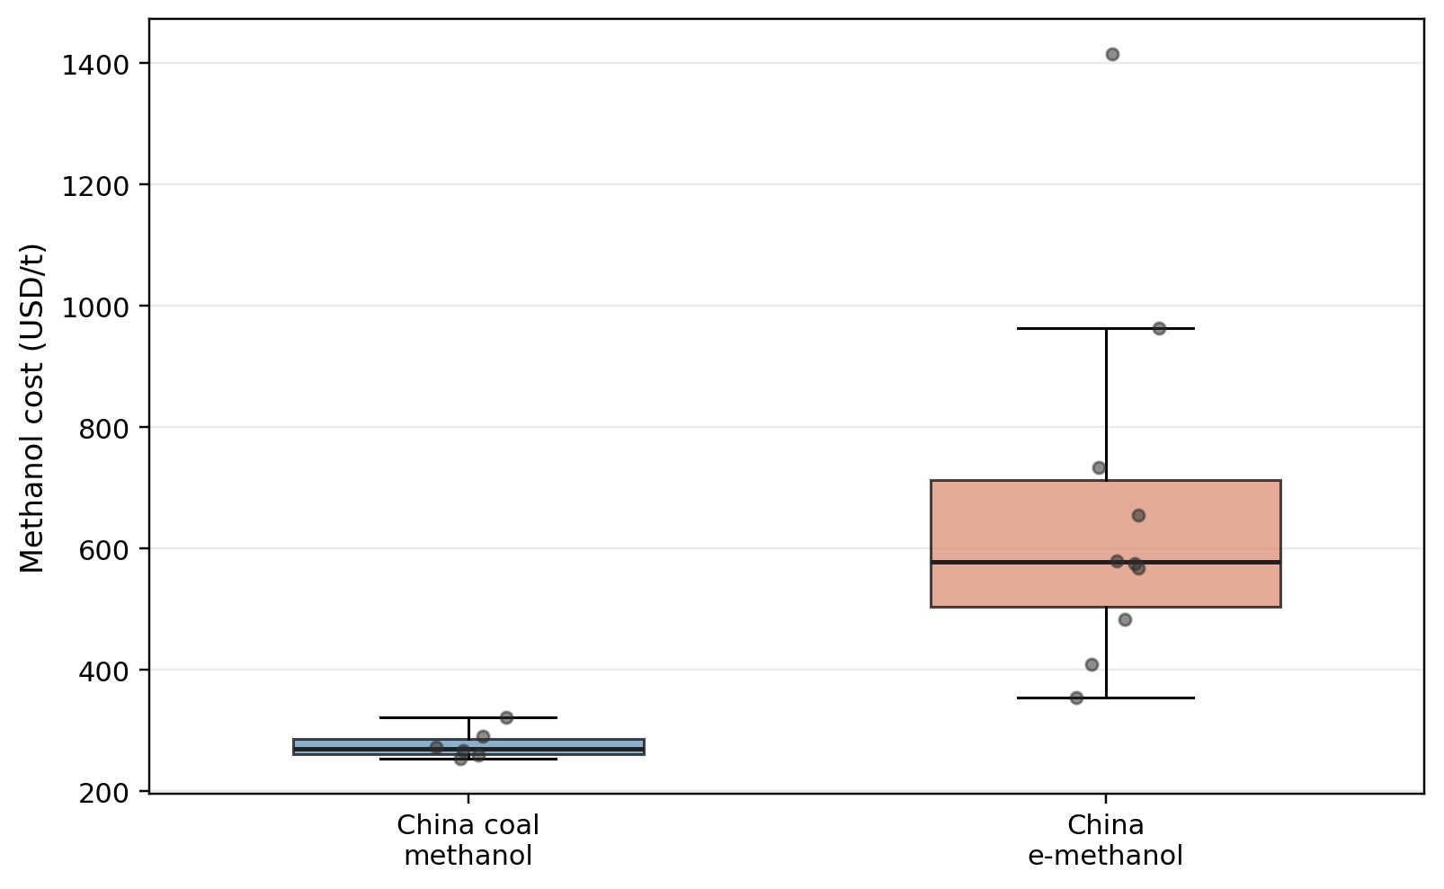
Figure 2. Production cost per tonne (USD) for coal methanol (N=6, median USD 269.8/t) and e-methanol (N=10, median USD 577.5/t) in the China-specific subsample (observations dated 2024 or earlier). The median cost gap is USD 307.7/t.
5.3 Long-run green-methanol trajectory
The current gap is large, but the long-run trajectory is not flat. Using projected e-methanol observations retained from Fasihi and Breyer (2024) and IRENA (2021), the thesis finds a clear downward trend in prospective e-methanol cost. The mean projected cost in the retained 2030 sample is USD 616.8/t. In the 2040 sample it falls to USD 442.5/t, and by 2050 to USD 359.0/t. These are not China-specific forecasts, but they are analytically useful because they show that the route can move into the broad fossil methanol cost band under favorable conditions over time. This future trajectory is best interpreted as evidence of conditional convergence rather than inevitable convergence; the projected decline rests on assumptions about cheaper renewable electricity, cheaper electrolyzers, larger plant scales, and better system utilization.
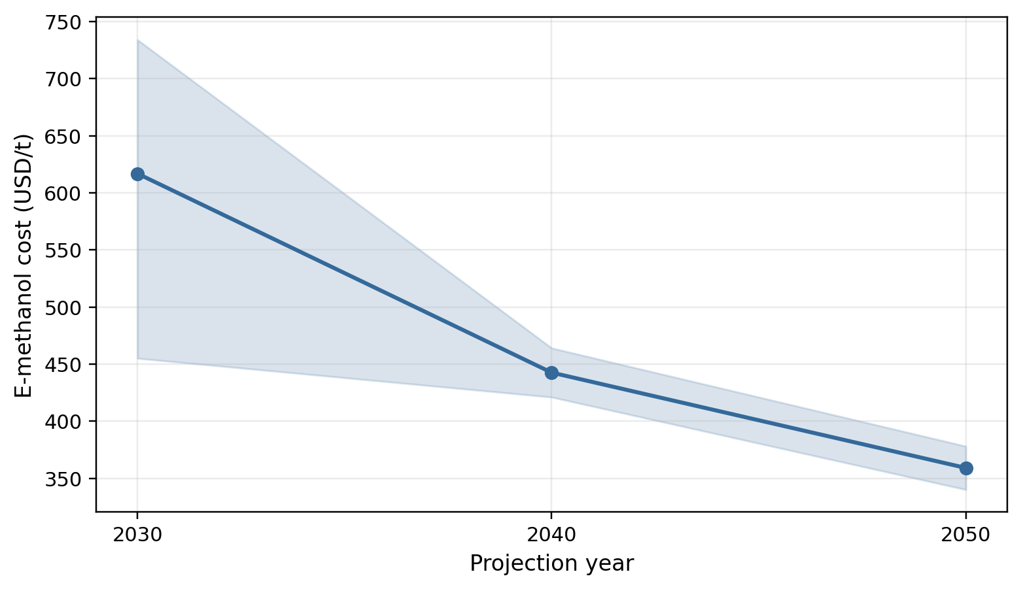
Figure 3. Projected e-methanol production cost per tonne (USD) from retained Fasihi and Breyer (2024) and IRENA (2021) scenarios. Mean projected cost declines from USD 616.8/t in 2030 to USD 442.5/t in 2040 and USD 359.0/t in 2050, approaching the current fossil methanol cost band.
Table 3. Baseline assumptions used in the stylized parity model.
Parameter | Value | Basis
Baseline China coal methanol cost | $269.8/t | Median of China coal-methanol literature observations (2017–2024)
Baseline China e-methanol cost | $577.5/t | Median of China e-methanol literature observations (2021–2024)
Current China cost gap | $307.7/t | Difference between the two medians
Coal-route CO₂ intensity | 2.3 tCO₂/t MeOH | Midpoint of 2.0–2.6 tCO₂/t range across retained coal-methanol sources
H₂ stoichiometric requirement | 0.1875 t H₂/t MeOH | CH₃OH synthesis stoichiometry (3 mol H₂ per mol methanol)
Electrolysis electricity intensity | 55 kWh/kg H₂ | Stylized assumption (lower bound; full-system is 12–14 MWh/t)
Implied electricity intensity per t MeOH | 10.3 MWh/t MeOH | 0.1875 t H₂/t × 55 kWh/kg H₂ (conservative, hydrogen component only)
Baseline green hydrogen cost | $3.85/kg | Current China green-hydrogen anchor from compiled scenario sources
Hydrogen share in e-methanol cost | 45% | Midpoint of 31%–59% range in Li P. et al. (2024a); not a symmetric average
Conventional capex benchmark | $722/tpy | Geismar 3 project capex intensity (USD 1.3B / 1.8M tpy) (Methanex, 2025)
Green capex benchmark | $2,048–$3,333/tpy | Kassø e-methanol project low and high cases

5.4 Carbon parity under alternative electricity assumptions
The first stylized parity model, reported in Table 4 and Figure 4, varies renewable-electricity cost. The result is straightforward: lower electricity prices materially reduce the carbon price required for parity. At a current-like electricity anchor of USD 36/MWh, parity requires approximately USD 133.8/tCO₂. At USD 33/MWh, the threshold is about USD 120.3/tCO₂. At USD 25/MWh, it falls to USD 84.5/tCO₂. At USD 20/MWh, it falls to USD 62.1/tCO₂, and at USD 15/MWh to USD 39.7/tCO₂.
These numbers matter because they show that carbon pricing and renewable-electricity cost cannot be discussed independently. If one assumes current Chinese carbon prices and current electricity costs, parity is distant. If one assumes falling renewable-electricity costs but no carbon pricing, parity remains difficult. If one assumes higher carbon pricing but no renewable cost decline, parity is still politically demanding. Competitiveness therefore emerges only under joint movement, which supports H3. Because the hydrogen requirement is embedded in e-methanol chemistry, electricity acts as a quasi-feedstock: a reduction of USD 10/MWh in renewable electricity corresponds to roughly USD 103/t in e-methanol cost reduction in the stylized model.
Table 4. Break-even carbon price under alternative renewable-electricity assumptions.
Electricity price (USD/MWh) | Carbon parity (USD/tCO₂)
15 | 39.7
20 | 62.1
25 | 84.5
33 | 120.3
36 | 133.8

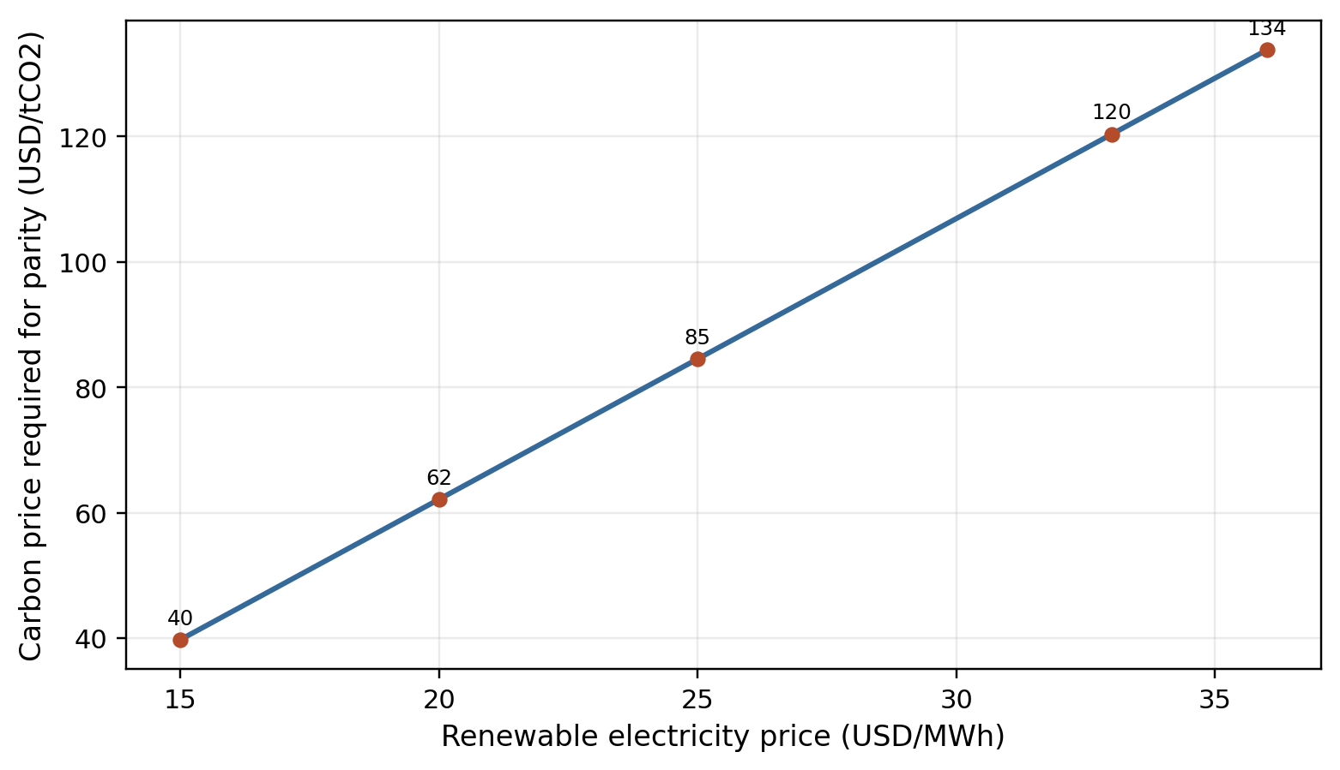
Figure 4. Break-even carbon price (USD/tCO₂) required for green methanol cost parity with coal methanol, plotted against five renewable electricity price levels (USD 15–36/MWh). Based on the stylized parity model: coal CO₂ intensity = 2.3 tCO₂/t; electricity sensitivity = 10.3 MWh/t methanol.
5.5 Carbon parity under alternative hydrogen assumptions
The second stylized parity model, reported in Table 5 and Figure 5, varies green-hydrogen cost. At the current USD 3.85/kg anchor, parity requires about USD 133.8/tCO₂. If green hydrogen falls to USD 2.24/kg, the implied parity carbon price falls to approximately USD 86.5/tCO₂. At USD 2.00/kg, it falls to USD 79.5/tCO₂. At the hydrogen cost used in the Zhou et al. (2024) indirect CO₂-to-methanol route (USD 1.88/kg), the model yields a parity carbon price of approximately USD 76.0/tCO₂. At USD 1.45/kg, the threshold falls to approximately USD 63.3/tCO₂.
These figures differ from the electricity-case results because the hydrogen-case model uses a proportional hydrogen-share assumption rather than a direct stoichiometric electricity translation. Even so, the substantive conclusion is the same: hydrogen cost is a major determinant of the competitive gap, and China's regional hydrogen-cost potential is strategically important. If northwest provinces can deliver materially cheaper green hydrogen, the economics of local green methanol projects improve much faster than national-average numbers would suggest (Li et al., 2024b).
A caveat follows. The USD 76.0/tCO₂ threshold at USD 1.88/kg hydrogen in the present model should not be confused with the Zhou et al. (2024) result that their specific indirect route reaches coal-methanol parity at USD 1.88/kg without additional carbon pricing. That result applies to a purpose-optimized configuration with ethylene glycol co-production that reduces effective methanol cost significantly below the China e-methanol median used here. The two analyses are answering different questions, and the discrepancy is explained by methodology, not by error in either study. Lower hydrogen cost is necessary but not sufficient for the median China green methanol project. If hydrogen becomes cheaper but carbon pricing remains negligible, a substantial gap persists.
Table 5. Break-even carbon price under alternative green-hydrogen assumptions.
Hydrogen cost (USD/kg) | Carbon parity (USD/tCO₂)
3.85 | 133.8
2.24 | 86.5
2.00 | 79.5
1.88 | 76.0
1.45 | 63.3

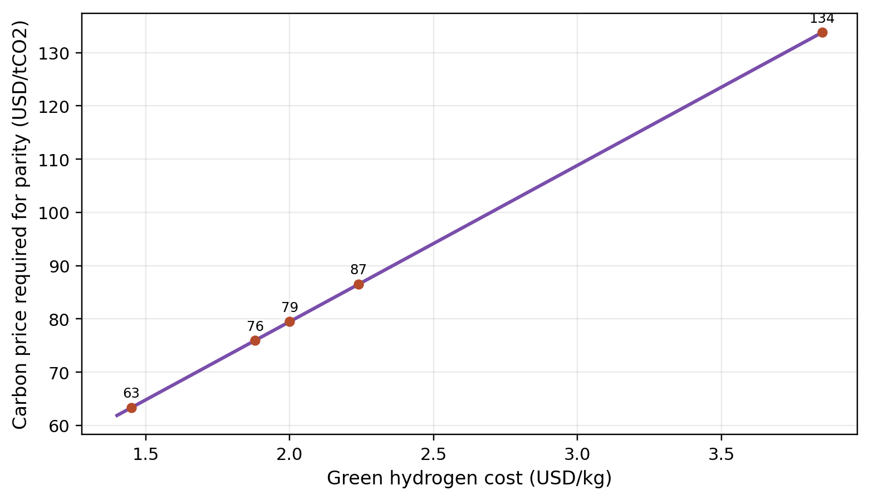
Figure 5. Break-even carbon price (USD/tCO₂) required for green methanol cost parity with coal methanol, plotted against five green hydrogen cost levels (USD 1.45–3.85/kg). At USD 2.00/kg hydrogen, the required carbon price is USD 79.5/tCO₂; at USD 1.45/kg, it falls to USD 63.3/tCO₂.
5.6 Company benchmark evidence
Public-company data, summarized in Table 6 and Figure 6, sharpen the financial interpretation of the cost results. Methanex Corporation remains the cleanest benchmark (Methanex, 2025). Between 2020 and 2024, Methanex's revenue per tonne ranged from roughly USD 246.7/t to USD 400.1/t, while EBITDA per tonne ranged from USD 32.2/t to USD 99.1/t. The implied blended cost per tonne ranged from about USD 214.5/t to USD 313.6/t. This is not a pure production-cost series because purchased methanol, logistics, and overhead are embedded in the commercial business. Nevertheless, it provides a strong sense of where incumbent methanol economics have actually operated in recent years.
Two conclusions follow from the Methanex evidence. First, the historical realized-price environment has not been rich enough to make a green-methanol cost base in the USD 500–700/t range broadly competitive on a merchant basis. Second, even incumbent methanol economics are cyclical, with EBITDA per tonne moving sharply over the period, meaning that any low-carbon project relying on merchant methanol prices faces substantial revenue risk without contractual support. Capex intensity tells the other half of the story. The Geismar 3 gas-methanol project implies a project capex intensity of around USD 722/tpy. By contrast, the Kassø e-methanol project cases retained in the dataset imply roughly USD 2,048/tpy and USD 3,333/tpy, suggesting that the green premium is not only an operating-cost issue but also a balance-sheet issue.
Table 6. Selected public-company benchmark metrics.
Source | Year | Pathway | Revenue/t (USD) | EBITDA/t (USD) | Capex intensityᵃ (USD/tpy) | Utilization (%)
Methanex (Methanex, 2025) | 2020 | Gas Methanol | 246.7 | 32.2 | — | 75.1
Methanex (Methanex, 2025) | 2021 | Gas Methanol | 394.8 | 99.1 | — | 73.9
Methanex (Methanex, 2025) | 2022 | Gas Methanol | 400.1 | 86.5 | — | 69.4
Methanex (Methanex, 2025) | 2023 | Gas Methanol | 333.3 | 55.7 | 50.9 | 75.4
Methanex (Methanex, 2025) | 2024 | Gas Methanol | 355.3 | 73.0 | 16.4ᵇ | 59.9ᵈ
OCI Global (OCI, 2025) | 2023 | Gas Methanol | 510.6 | 51.9 | 17.1 | —
European Energy (Kassø) | 2025 | Green Methanol | — | — | 2,047.6 | —
European Energy (Kassø) | 2025 | Green Methanol | — | — | 3,333.3 | —

ᵃ CAPEX intensity for Methanex annual rows reflects total capital expenditure for that year divided by nameplate capacity and represents a maintenance-and-growth spending rate, not a project construction cost. The Kassø figures are project capex for a new facility and are not directly comparable. Geismar 3 cost USD 1.3 billion for 1.8 million tpy of new capacity, implying a project capex intensity of USD 722/tpy (Methanex, 2025).
ᵇ 2024 annual capex of USD 174 million divided by total nameplate capacity of 10.61 million tpy reflects primarily maintenance spending after Geismar 3 was completed. The Geismar 3 project construction cost is separately reported at USD 1.3 billion total.
ᵈ Methanex 2024 utilization of 59.9% reflects partial-year availability of Geismar 3 (1.8 million tpy), which completed commercial performance tests in October 2024 and was unavailable for approximately nine months of the year. Utilization on available capacity was approximately 75–80%.
China Coal Energy (China Coal Energy, 2025) and China Shenhua (China Shenhua Energy, 2025) remain in the underlying dataset but are omitted from this condensed table because their disclosures are not methanol-pure.
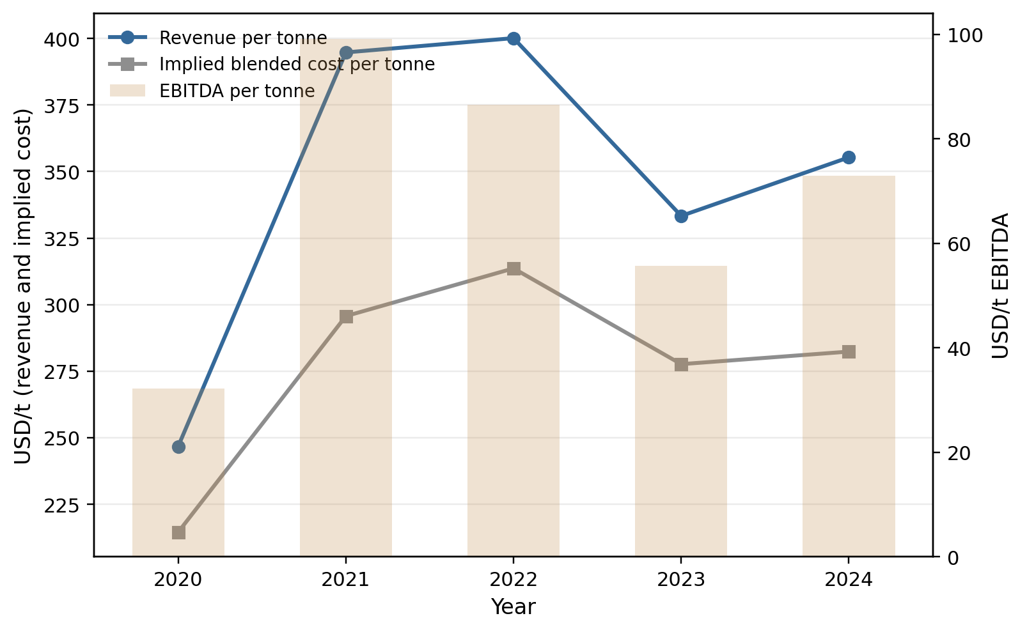
Figure 6. Methanex Corporation (NASDAQ: MEOH) financial performance per tonne of methanol sold, fiscal years 2020–2024: average realized price (USD/t), implied blended cost per tonne (revenue minus EBITDA divided by sales volume), and EBITDA per tonne. Source: Methanex Form 40-F filings (Methanex, 2025).
5.7 Stylized project valuation
The preceding sections establish the cost gap and the conditions under which it narrows. This section translates those findings into a financial interpretation by computing illustrative net present values and internal rates of return for representative methanol projects. The purpose is not to model any specific plant in detail but to show how the cost-gap results translate into investment attractiveness across different conditions, following the approach developed by Larsen and Brenøe (2022) for early-stage green transition projects.
Five stylized scenarios are analyzed, all assuming a representative plant with nameplate capacity of 200,000 tonnes per year. This scale was chosen because it sits in the middle of the range of commercially announced green methanol projects: the Kassø facility operates at 42,000 tpy while projects such as C2X target 500,000+ tpy. At 200,000 tpy, the plant is large enough to support realistic capital structure assumptions while small enough to avoid scale advantages that are not yet reproducible. The plant operates at 85% utilization (170,000 t/yr annual production) over a 20-year project life with a 25% China corporate tax rate. Free cash flow is computed as net operating profit after tax plus straight-line depreciation over 20 years. The discount rate is 8% for coal methanol projects and 10% for green methanol projects, reflecting the different financing environments discussed in Section 4.7. The baseline methanol market price is USD 340/t, representing a conservative China domestic average consistent with the 2022–2023 period. The coal methanol CAPEX assumption of USD 200/tpy reflects documented Chinese coal chemical construction economics, which are materially lower than international benchmarks because of lower engineering and labour costs and simpler designs without integrated carbon capture (Tu, 2024; Xu et al., 2017); this compares with the Saudi Arabian design cases in Khalafalla et al. (2020) which include CCS and carry substantially higher unit costs. Green methanol CAPEX figures are derived as follows. Scenarios 3 and 4 use USD 1,250/tpy, representing approximately 60 percent of the lower Kassø benchmark of USD 2,048/tpy, adjusted downward for Chinese construction cost economics. Chinese coal-chemical plant construction costs are documented at 30–50 percent below European equivalents due to lower engineering, procurement, and construction labour costs (Tu, 2024; Xu et al., 2017), and similar discounts apply to green hydrogen and methanol synthesis equipment procured domestically. Scenario 5 uses USD 750/tpy, reflecting: (a) a China-adjusted construction discount of approximately 40 percent from USD 1,250/tpy, and (b) projected 2030 technology learning in electrolyzers, which the IEA (2024a) projects will reduce Chinese alkaline system costs to approximately USD 200–400/kW by 2030 compared with USD 600–1,200/kW in 2024—a reduction that directly compresses total green methanol plant capex intensity. The USD 750/tpy figure is therefore a construction-cost-adjusted, learning-curve-incorporating estimate, not a direct Kassø scaling. The revenue assumptions in each scenario reflect different market-access conditions, not different product quality. Scenario 3 uses the commodity methanol price of USD 340/t, the same price available to coal methanol producers, to test whether green methanol can compete across any market without a premium. Scenarios 4 and 5 use above-commodity prices of USD 700/t and USD 580/t respectively, reflecting the compliance-driven premium that maritime shipping buyers currently pay under long-term bilateral offtake agreements to meet IMO 2023 GHG Strategy and FuelEU Maritime obligations. This premium is not available in the formaldehyde, MTO, or MTBE markets. A green methanol project selling into those commodity applications would face Scenario 3 economics regardless of its green credentials, making those pathways non-viable until production-cost parity is actually reached.
Table 7. Stylized project NPV and IRR under alternative scenarios.
Parameter | Sc.1: Coal Current | Sc.2: Coal $80 Carbon | Sc.3: Green Merchant | Sc.4: Green Offtake | Sc.5: Green 2030
Pathway | Coal Methanol | Coal Methanol | Green Methanol | Green Methanol | Green Methanol
CAPEX ($M) | 40 | 40 | 250 | 250 | 150
CAPEX intensity ($/tpy) | 200 | 200 | 1,250 | 1,250 | 750
Production cost ($/t) | 270 | 270 | 577 | 577 | 450
Carbon cost ($/t) | 32 | 184 | 0 | 0 | 0
Revenue ($/t) | 340 | 340 | 340 | 700 | 580
EBITDA/t ($) | 38 | −114 | −237 | 123 | 130
Annual EBITDA ($M) | 6.5 | −19.4 | −40.3 | 20.9 | 22.1
Annual FCF ($M) | 5.4 | neg. | neg. | 18.8 | 18.5
Discount rate | 8% | 8% | 10% | 10% | 10%
NPV ($M) | +13 | −230 | −593 | −90 | +7
IRR | ~12% | N/A | N/A | ~4% | ~10%
Payback period (yrs) | 7.4 | N/A | N/A | >20 | 8.1

Assumes 200,000 tpy nameplate capacity, 85% utilization, 20-year life, 25% tax rate, straight-line depreciation. Carbon price in Scenario 1: USD 14/tCO₂ (China ETS 2024 peak (ICAP, 2025)); Scenario 2: USD 80/tCO₂ (illustrative policy scenario). E-methanol scenarios exclude direct carbon cost (near-zero direct CO₂ emissions). Discount rates: 8% coal/state-enterprise, 10% private/emerging technology. These are stylized scenarios, not plant-specific forecasts.
The results in Table 7 show a clear progression. Under current conditions, coal methanol is commercially viable with a positive NPV of approximately USD 13 million and an IRR near 12%, consistent with its role as an established industrial asset in China. However, a carbon price of USD 80/tCO₂—well below the World Bank's recommended effective price range for Paris-aligned pathways (World Bank, 2025) but above today's Chinese ETS levels—turns coal methanol cash-flow negative, destroying project value entirely.
Scenario 2 confirms that carbon pricing at USD 80/tCO₂ renders coal methanol unviable: FCF = EBITDA = −USD 19.4M/yr (no tax benefit applies to loss-making years), giving NPV = −USD 19.4M × 9.82 − USD 40M = −USD 190M − USD 40M = −USD 230M, consistent with Table 7.
Green methanol on a fully merchant basis is not financially viable under any near-term scenario. Scenario 3 FCF = EBITDA = −USD 40.3M/yr (no tax benefit applies to loss-making operations; depreciation nets to zero since there is no taxable income). NPV = −USD 40.3M × 8.514 − USD 250M = −USD 343M − USD 250M = −USD 593M, producing a deeply negative NPV of approximately USD 593 million and reflecting an EBITDA loss of USD 237/t at current production costs. The introduction of a long-term offtake agreement at USD 700/t—a premium consistent with early green methanol contracts in the shipping sector (OCI, 2024)—significantly improves the picture but does not by itself make the project financially viable: NPV remains negative at approximately USD 90 million, and the IRR of approximately 5% falls well below the assumed 10% hurdle rate. This result explains why early green methanol projects have required additional support through policy incentives, carbon credits, strategic integration, or equity from parties with non-financial motives, in addition to offtake contracts alone.
The 2030 scenario, in which production costs fall to USD 450/t---consistent with the lower range of China-specific scheduling-optimized projections in Li P. et al. (2024a) (USD 409--568/t for optimized pathways) and reflecting technology learning in advantaged Chinese locations rather than the global mean of USD 616.8/t reported in Section 5.3---and where a long-term offtake price of USD 580/t reflects green methanol pricing near the coal parity threshold with a modest premium for low-carbon supply — critically, even in this 2030 optimistic scenario the compliance premium above commodity price ($580/t vs. $340/t commodity = $240/t premium) is still required; at commodity pricing of $340/t the 2030 project EBITDA would be $340 − $450 = −$110/t, still loss-making, produces a barely positive NPV of approximately USD 7 million and an IRR near 10%. This is borderline viability: the project earns its cost of capital but generates minimal surplus value for investors. It does, however, represent a plausible first-mover investment case in an environment where carbon regulation is tightening and green methanol supply remains constrained.
The key insight is that no single lever is sufficient. Carbon pricing alone at currently projected Chinese ETS levels does not make green methanol viable. Offtake alone at achievable premiums does not close the gap at current production costs. Technology cost reduction alone, even under optimistic 2030 projections, leaves the project at the hurdle rate boundary. What produces a positive investment case is the simultaneous movement of all three: technology cost decline, meaningful carbon pricing, and secured long-term offtake. That is precisely the joint condition described in H3, now confirmed in both the cost-parity and the valuation dimensions.

6. Discussion
6.1 Interpreting the hypotheses
The empirical results support H1 clearly. In the current China sample, green methanol remains materially more expensive than coal methanol. The size of the median gap—USD 307.7/t—is large enough to survive reasonable variations in sample construction. Any argument claiming current commercial parity in China would require either a very unusual project configuration or a different system boundary than the one used here. It is also worth stating explicitly that the USD 307.7/t median cost gap is measured at the production gate for the same chemical product. This does not mean that a green methanol project commercially competitive in maritime supply — where buyers pay a compliance premium — is immediately competitive across all of coal methanol's end-use markets. The thesis distinguishes between cost parity, which is the focus of Sections 5.1 through 5.5, and full market displacement, which requires cost parity across all end-uses without a compliance premium. The latter is a more demanding condition and is not claimed to be near.
H2 is also supported, though with a nuance that matters. The evidence indicates that hydrogen cost and renewable-electricity cost are the most powerful levers, but they are not the only ones. Carbon-source choice, plant utilization, and co-product treatment also matter substantially, as demonstrated by the cases from Gu et al. (2022), Li P. et al. (2024a), and Zhou et al. (2024). Green methanol does not have a single deterministic cost function; it has a family of possible cost structures. The thesis therefore interprets H2 as a claim about dominant drivers, not exclusive drivers.
H3 is supported conditionally—and the project valuation in Section 5.7 reinforces this conclusion from the investment side. The parity analysis shows that no single variable is sufficient to close the gap. The NPV analysis shows that no single lever is sufficient to produce a viable investment case. The two frameworks therefore tell a consistent story: green methanol becomes both cost-competitive and financially attractive only when carbon pricing, technology cost decline, and secured offtake move together.
6.2 Why the scientific side matters for the finance side
A common weakness in finance-oriented discussions of transition technologies is that engineering is treated as background detail. In methanol, that approach fails. The hydrogen requirement is not a managerial preference; it is dictated by methanol synthesis chemistry. The electricity burden is not a rhetorical framing; it is the physical consequence of producing that hydrogen through electrolysis. Carbon-source cost and purity affect not only sustainability claims but real plant economics. Utilization is not an accounting footnote; it is the mechanism through which variable renewable output becomes a financial cost. This is why a finance thesis on methanol must remain grounded in technical logic.
6.3 Why global evidence remains useful even in a China-focused thesis
Global evidence is useful for descriptive benchmarking because it shows the broad technological landscape: how coal, gas, bio, and e-methanol compare internationally, how wide each cost distribution is, and how far future projections move relative to current fossil ranges. It is not appropriate, however, to use global best-site values directly as China current policy inputs. That is why the thesis uses a two-stage design: global evidence for descriptive context, China-specific evidence for parity modeling. This distinction improves rather than weakens the analysis.
6.4 Policy implications for China
The policy implications are clear. First, current Chinese ETS prices—peaking at approximately RMB 104.5/tonne (USD 14.4/tCO₂) in late 2024 (ICAP, 2025)—are not high enough to close the methanol competitiveness gap on their own. At 2.3 tCO₂/t methanol, that adds only USD 33/t to coal methanol's effective cost, against a USD 307.7/t gap. Even under the World Bank's State and Trends of Carbon Pricing (World Bank, 2025) recommended price range for Paris-aligned pathways, carbon pricing alone remains insufficient at today's renewable electricity and hydrogen costs. This does not mean carbon pricing is irrelevant. It means it is necessary but insufficient.
Second, renewable-electricity deployment is not merely a power-sector story. In the methanol context, cheaper renewable electricity directly reduces the cost of hydrogen and therefore the cost of e-methanol. Policies that lower delivered renewable-electricity cost in resource-rich provinces can have an outsized effect on downstream green-fuel economics. Third, hydrogen policy matters because hydrogen cost is the principal bridge variable between the power system and the methanol system. China's advantage in renewable deployment and lower electrolyzer manufacturing cost (IEA, 2024a) could translate into a real green-methanol advantage over time if accompanied by infrastructure, siting discipline, and offtake development. Fourth, carbon-source strategy should not be ignored: near- and medium-term green-methanol deployment is more likely to emerge from point-source capture, biogenic carbon, or integrated industrial systems than from pure DAC-based projects.
6.5 Corporate-finance implications
From a corporate-finance perspective, the most important result is that current green methanol economics remain difficult to support on a fully merchant basis. The Methanex benchmark (Methanex, 2025) shows that realized methanol markets can be profitable for incumbents, but also highly cyclical. A green project carrying a USD 307.7/t production cost premium and roughly three to five times the capex intensity of a conventional gas methanol plant is unlikely to clear a conventional merchant hurdle rate without support, as demonstrated by the NPV results in Section 5.7.
That support can take several forms: policy support including carbon pricing, production incentives, or contracts for difference; offtake support where shipping companies or industrial buyers sign long-term purchase agreements that improve revenue certainty; and strategic integration where renewable generation, hydrogen production, carbon sourcing, and methanol synthesis are optimized as a system. The Larsen and Brenøe (2022) framework for valuing early-stage green transition projects is directly applicable here: projects may become commercially interesting before they are commercially optimal if strategic offtake structures and policy support can bridge the gap to maturity. Early green methanol commercialization in the shipping sector (OCI, 2024; OCI, 2025) is consistent with this logic: it has emerged first in settings tied to strategic demand, not in purely merchant commodity markets.
6.6 Limits of parity as a decision rule
Although parity is a useful metric, it should not be fetishized. A project can become interesting before exact parity if it has privileged market access, strategic offtake, or policy support. Conversely, a project that appears to reach parity in a stylized model may still be unattractive if its capex is excessive, its utilization uncertain, or its carbon accounting contested. The value of parity analysis in this thesis is diagnostic rather than deterministic: it identifies the order of magnitude of the challenge, the direction of movement required, and the variables with the largest leverage.
6.7 Strategic implications for siting, sequencing, and industrial organization
Because renewable-electricity price, hydrogen cost, and utilization are so influential, green methanol is unlikely to diffuse evenly across China. It is more likely to concentrate first in provinces that combine strong renewable resources, lower land constraints, access to carbon streams, and credible offtake pathways. Inner Mongolia and Gansu are repeatedly relevant in the broader hydrogen literature for this reason (Li et al., 2024b). Sequencing matters as well: the most plausible near-term route is staged development, beginning with demonstration and niche commercialization where offtake, policy support, or industrial integration can sustain a premium, expanding in advantaged regions as hydrogen and electricity costs fall, and approaching broader commodity competition if carbon prices and technology learning jointly compress the gap. This staged view is more consistent with the data than narratives of abrupt displacement.
Industrial organization is another underappreciated issue. Coal methanol in China is often embedded in integrated parks and broader coal-chemical portfolios, benefiting from integration advantages not visible in a simple per-tonne cost comparison. Green methanol projects that integrate renewable generation, electrolysis, CO₂ supply, and downstream offtake may replicate some of those incumbency advantages in a new form. The strongest business cases are likely to emerge where developers control or contract multiple parts of the chain. Projects exposed to merchant risk on all fronts face a much steeper challenge. The market segmentation point reinforces this sequencing logic. Green methanol's near-term commercial viability depends on securing access to the maritime compliance market, where buyers pay above-commodity prices. That niche is defined by IMO and FuelEU Maritime regulation, not by Chinese domestic demand. Once green methanol production costs fall far enough to compete at commodity price levels in formaldehyde, MTO, and MTBE applications — the markets where coal methanol is strongest — the transition becomes self-sustaining without regulatory support. The break-even thresholds calculated in this thesis represent the price levels at which that commodity-market transition becomes possible, not merely the niche-market transition that is already underway through maritime offtake.

7. Conclusion
This thesis set out to answer a practical and financially relevant question: under what conditions can green methanol become competitive with coal-to-methanol in China? The direct answer is this: green methanol becomes cost-competitive with coal methanol in China when three conditions are simultaneously met. First, renewable electricity in China's high-resource provinces must fall to approximately USD 20–25 per MWh, which is achievable in Inner Mongolia and Gansu on current trajectory by the late 2020s. Second, green hydrogen must fall to approximately USD 1.45–2.00 per kg, which requires electrolyzer capital costs of USD 200–400/kW and capacity factors above 50%—targets that China's electrolyzer manufacturing base makes plausible before 2030. Third, China's carbon price must rise to USD 62–80 per tonne of CO₂, between four and six times today's level, to add USD 143–184 to coal methanol's effective cost per tonne. Under these three joint conditions, a 200,000-tonne-per-year green methanol plant achieves an IRR of approximately 10%, its cost of capital. Under current conditions, that same plant produces a net present value of negative USD 593 million.
Yet the gap is not immutable. The empirical results show that green methanol can move into a competitive zone when multiple conditions improve together. Lower renewable-electricity cost reduces the effective hydrogen burden. Lower hydrogen cost directly compresses the cost premium. Higher carbon pricing erodes coal methanol's incumbent advantage. The project valuation confirms that the joint condition required for cost parity is also the joint condition required for investment viability: no single lever is sufficient, and all three must move simultaneously for a green methanol project to clear its cost of capital.
The thesis therefore rejects both simplistic extremes. It rejects the claim that green methanol is already broadly competitive in China today. It also rejects the claim that green methanol is merely aspirational and commercially irrelevant. The more accurate conclusion is conditional convergence: the pathway becomes plausible within a definable zone shaped by electricity, hydrogen, carbon pricing, utilization, and capital intensity.
For managers and investors, the implication is clear. The key question is not whether to compare green methanol with coal methanol, but how to structure projects so that the most important drivers move in the right direction simultaneously. For policymakers, carbon pricing combined with cheaper renewable electricity, hydrogen infrastructure, and credible offtake support can materially change the investment landscape. For scholarship, the contribution is to show that an integrated view—one that respects chemistry, engineering, policy, and finance at the same time—produces a more realistic account of the transition challenge than any one of those lenses alone.
The most valuable next step for future research would be to pair the framework developed here with plant-specific Chinese project data on capex, debt structure, contracting, and carbon-source logistics. That would allow the parity logic and valuation framework in this thesis to be extended into a fuller discounted-cash-flow model with explicit financing assumptions. Even without that project-level detail, the present study shows that competitiveness analysis is already much stronger when it combines literature evidence, scenario inputs, and company benchmarks rather than relying on any one source type alone.

Appendix A. Analytical Tables
Appendix Table A1. Hypothesis assessment.
Hypothesis | Assessment | Evidence
H1 | Supported in the current sample | Median current China coal methanol cost is USD 269.8/t versus USD 577.5/t for China e-methanol, implying a USD 307.7/t gap.
H2 | Supported directionally | Sensitivity analysis shows that lower renewable electricity and lower hydrogen costs materially compress the green-methanol premium. Carbon-source choice and utilization are secondary amplifiers.
H3 | Supported conditionally, confirmed in both cost and valuation dimensions | At USD 36/MWh electricity, carbon parity requires about USD 133.8/tCO₂; the threshold falls materially at lower electricity and hydrogen costs. NPV analysis (Table 7) confirms that no single lever produces a viable investment case; joint movement in technology, carbon pricing, and offtake is required for IRR ≥ 10%.

Appendix Table A2. Sample construction and analytical subsets.
Analytical sample | Rows | Definition
Raw structured master sheet | 84 | All company, literature, and scenario rows.
Cost comparison sample | 43 | Rows with MethanolCost_USD_t populated and a methanol pathway label.
Company benchmark sample | 14 | Company rows retained for revenue, EBITDA, capex, and utilization benchmarking.
Scenario / threshold inputs | 46 | Rows used to parameterize electricity, hydrogen, carbon-price, and electrolyzer-capex scenarios, including NPV inputs.

Appendix B. Formula Notes for the Stylized Parity Model
The stylized parity model is intentionally simple enough to be audited line by line. For the electricity case, the model begins with the current China median e-methanol cost of USD 577.5/t and the current China median coal-methanol cost of USD 269.8/t. The difference is USD 307.7/t. Coal methanol is assigned a central carbon intensity of 2.3 tCO₂ per tonne of methanol. If carbon pricing is introduced, the effective coal cost becomes:
Effective coal cost = 269.8 + 2.3 × carbon price.
The e-methanol electricity sensitivity is based on two transparent assumptions: methanol synthesis requires 0.1875 tonnes of hydrogen per tonne of methanol on a stoichiometric basis; and electrolysis consumes 55 kWh/kg H₂ in the stylized base case. Note that this 10.3 MWh/t figure understates full-system electricity intensity, which typically ranges from 12 to 14 MWh/t. The electricity-case equation therefore becomes:
Scenario e-methanol cost = 577.5 − 10.3 × (36 − scenario electricity price),
where USD 36/MWh is the baseline electricity anchor. Parity is reached when effective coal cost equals scenario e-methanol cost.
For the hydrogen case, the model uses literature evidence that hydrogen accounts for roughly 31%–59% of e-methanol cost in the retained Li P. et al. (2024a) cases. The central case adopts the midpoint share of 45%. The hydrogen component of baseline e-methanol cost is therefore approximated as 0.45 × 577.5. That component is scaled in proportion to changes in hydrogen price relative to the baseline USD 3.85/kg anchor:
Scenario e-methanol cost = 577.5 − [0.45 × 577.5 × (1 − scenario hydrogen price / 3.85)].
For the project valuation, free cash flow is defined as:
FCF = (Revenue − Operating cost − Carbon cost − Depreciation) × (1 − tax rate) + Depreciation
where depreciation = CAPEX / project life. NPV is then the sum of discounted annual FCFs minus the initial CAPEX. IRR is the discount rate that sets NPV to zero.

Appendix C. Data Provenance and Interpretation Rules
The empirical analysis relies on three classes of source. The first is peer-reviewed techno-economic literature, which provides most of the direct methanol-cost observations used in the descriptive analysis. The second is institutional or industry reports, including IRENA (2021), IEA (IEA, 2024a; IEA, 2024b), ICAP (ICAP, 2025), and World Bank (World Bank, 2025), which provide policy and technology scenario anchors. The third is public-company disclosure: annual reports and SEC filings from Methanex (Methanex, 2025), annual reports from OCI Global (OCI, 2024; OCI, 2025), and exchange filings from China Coal Energy (China Coal Energy, 2025) and China Shenhua (China Shenhua Energy, 2025). Each class of source is used for a different purpose and should not be substituted for another.
Interpretation follows four rules. First, company blended cost metrics are not treated as equivalent to literature LCOM values. Second, projected 2030–2050 e-methanol observations are not mixed into the current China parity baseline. Third, scenario rows such as carbon prices and electricity costs are not counted as methanol-cost observations. Fourth, broad coal-chemical segment data are interpreted directionally unless the disclosure isolates methanol directly. These rules turn a heterogeneous source base into a defensible analytical structure.

References
Bazaluk, Oleg, et al. "Assessment of Green Methanol Production Potential and Related Economic and Environmental Benefits: The Case of China." Energies, vol. 13, no. 12, 2020, p. 3113. doi:10.3390/en13123113.
China Coal Energy Company Limited. Annual Report 2024. China Coal Energy, 2025. en.chinacoalenergy.com/col/col4818/art/2025/art_bff6df2a6cc04f12a46d612ce771170b.html.
China Shenhua Energy Company Limited. Annual Report 2024. China Shenhua Energy, 2025. en.shenhuachina.com.
Fasihi, Mahdi, and Christian Breyer. "Global Production Potential of Green Methanol Based on Variable Renewable Electricity." Energy & Environmental Science, vol. 17, 2024, pp. 3503–3522. doi:10.1039/D3EE02951D.
Gu, Yifan, et al. "Techno-Economic Analysis of Green Methanol Plant with Optimal Design of Renewable Hydrogen Production: A Case Study in China." International Journal of Hydrogen Energy, vol. 47, no. 9, 2022, pp. 4904–4919. Available online 8 Dec. 2021. doi:10.1016/j.ijhydene.2021.11.148.
International Carbon Action Partnership. "China National ETS." ICAP, 2025. icapcarbonaction.com/en/ets/china-national-ets.
International Energy Agency. Global Hydrogen Review 2024. IEA, 2024. iea.org/reports/global-hydrogen-review-2024.
International Energy Agency. Enhancing China's ETS for Carbon Neutrality: Introducing Auctioning. IEA, 2024. iea.org/reports/enhancing-chinas-ets-for-carbon-neutrality-introducing-auctioning.
International Renewable Energy Agency. Innovation Outlook: Renewable Methanol. IRENA and Methanol Institute, 2021. irena.org/publications/2021/Jan/Innovation-Outlook-Renewable-Methanol.
Khalafalla, Saad S., et al. "Conceptual Design Development of Coal-to-Methanol Process with Carbon Capture and Utilization." Energies, vol. 13, no. 23, 2020, p. 6421. doi:10.3390/en13236421.
Larsen, E. L., and E. E. Brenøe. Valuation of Early-Stage Green Transition Projects: A Case Study of Green Methanol in Shipping. Unpublished master's thesis, Copenhagen Business School, 2022. Cited for its discounted cash flow valuation framework; methodology is consistent with peer-reviewed energy transition finance literature (Li et al., 2021; Fasihi and Breyer, 2024). Not a peer-reviewed journal article.
Li, Peng, et al. "Feasibility Study of Renewable E-Methanol Production: A Substitution Pathway from Blue to Green." iEnergy, vol. 3, 2024, pp. 340–353. doi:10.23919/IEN.2024.0013.
Li, Xiaoyang, et al. "Levelized Cost Analysis of Onshore Wind-Powered Hydrogen Production System in China Considering Landform Heterogeneity." Energy, vol. 313, 2024, p. 133942. doi:10.1016/j.energy.2024.133942.
Li, Yang, et al. "A Quantitative Roadmap for China towards Carbon Neutrality in 2060 Using Methanol and Ammonia as Energy Carriers." iScience, vol. 24, no. 6, 2021, p. 102513. doi:10.1016/j.isci.2021.102513.
Luo, Shuai, et al. "A Novel Methanol Futures Price Prediction Method Based on Multicycle CNN-GRU and Attention Mechanism." Arabian Journal for Science and Engineering, vol. 48, 2023, pp. 1487–1501. doi:10.1007/s13369-022-06902-6.
Lv, Lei, et al. "Carbon Tax to Phase Out Coal as Propylene Feedstock and Control Upstream Methane Emissions in China: Based on Dynamic Radiative Forcing." Journal of Cleaner Production, vol. 466, 2024, p. 142839. doi:10.1016/j.jclepro.2024.142839.
Methanex Corporation. Annual Report 2024. Methanex, 2025. methanex.com/investors/financial-reports/. Data cited for fiscal years 2020–2024 from annual reports filed with the U.S. Securities and Exchange Commission as Form 40-F (CIK 0000886977). Five-year financial summary tables appear in each annual report glossy PDF; quarterly management discussion and analysis reports filed as exhibits provide per-tonne cash cost and production-site data.
OCI N.V. Annual Report 2023. OCI Global, 2024. investors.oci-global.com/sites/default/files/2024-04/OCI-Annual-Report-2023-vf_0.pdf.
OCI N.V. Annual Report 2024. OCI Global, 2025. investors.oci-global.com/sites/default/files/2025-03/OCI-Annual-Report-2024_0.pdf.
Tu, Kevin Jianjun. Prospects of the Chinese Coal Chemical Industry in an Increasingly Carbon-Constrained World. OIES Paper CE13, Oxford Institute for Energy Studies, 2024. oxfordenergy.org/wpcms/wp-content/uploads/2024/02/CE13-Prospects-of-the-Chinese-coal-chemical-industry_FINAL.pdf.
World Bank. State and Trends of Carbon Pricing 2025. World Bank, 2025. worldbank.org/en/publication/state-and-trends-of-carbon-pricing.
Xiang, Dong, et al. "Highly Efficient Carbon Utilization of Coal-to-Methanol Process Integrated with Chemical Looping Hydrogen and Air Separation Technology: Process Modeling and Parameter Optimization." Journal of Cleaner Production, vol. 258, 2020, p. 120910. doi:10.1016/j.jclepro.2020.120910.
Xu, Xianguo, et al. "Clean Coal Technologies in China Based on Methanol Platform." Catalysis Today, vol. 298, 2017, pp. 61–68. doi:10.1016/j.cattod.2017.05.070.
Yang, Jun, et al. "Scrutinizing Multi-Scale and Multi-Quantile Interactions in Commodity Markets: A Petrochemical Industrial Chain Perspective." Energy Economics, vol. 140, 2024, p. 108019. doi:10.1016/j.eneco.2024.108019.
Zhou, Hao, et al. "Viable Alternative Prospective Option for Liquid Methanol Industry's Long-Term and Cost-Effective Development: CO₂-to-Methanol Conversion and Ethylene Glycol Coproduction." ACS Sustainable Resource Management, vol. 1, 2024, pp. 374–384. doi:10.1021/acssusresmgt.3c00020.
ICAP (International Carbon Action Partnership). "China National ETS." ICAP Emissions Trading Worldwide Status Report, 2025. icapcarbonaction.com/en/ets/china-national-ets.
NDRC (National Development and Reform Commission, Ministry of Industry and Information Technology, Ministry of Natural Resources, Ministry of Ecology and Environment, Ministry of Water Resources, National Energy Administration). "Notice on Promoting Healthy Development of the Modern Coal Chemical Industry" (发改产业〔2023〕773号). NDRC, June 14, 2023. ndrc.gov.cn/xxgk/zcfb/tz/202307/t20230727_1358715.html.
MEE (Ministry of Ecology and Environment of the People's Republic of China). Progress Report of China's National Carbon Market (2024). MEE, July 2024. mee.gov.cn.
MIIT/NDRC/NEA (Ministry of Industry and Information Technology, National Development and Reform Commission, National Energy Administration). "Implementation Plan for Accelerating Clean and Low-Carbon Hydrogen in the Industrial Field." Joint Ministerial Notice, December 30, 2024.
ClearBlue Markets. "China's Carbon Market: The Evolution, Challenges, and Opportunities." ClearBlue Markets Knowledge Base, 2025. clearbluemarkets.com.

